Garden Volunteer – Wester Kittochside Farm Garden
The National Museum for Rural Life East Kilbride

Directorate:  South and West | 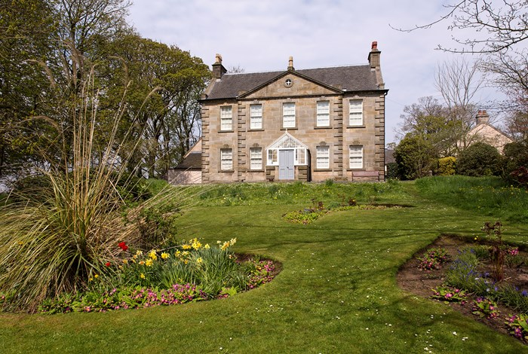
Volunteer Manager:
Juliet Turner, Gardener
Suggested Time Commitment:
Thurs 10am-2pm
Type of role:
Ongoing

Why do you need me?
The Wester Kittochside Farm at National Museum of Rural Life was owned and run by the Reid family for more than 400 years. The tenth and last Laird of Wester Kittochside left the farm to the National Trust for Scotland in 1992 and it is now run in partnership with National Museums Scotland. The small triangular Kitchen Garden survives, having provided the household with fruit and vegetables. Surrounding the house are the Ornamental Garden or Front Lawn, the East Gable Shrubbery and the Woodland Garden.

What’s included in the role?
- Weeding, lawn and box hedge maintenance, pruning, leaf blowing, plant care, bulb planting, all depending on the season and the weather.
- You may be approached by visitors, so we ask that you provide them with a friendly welcome and ensure they have a pleasant and informative experience

Why should I volunteer in this role?
- Trust volunteers can attend special events such as training sessions and are recognised for their work through our national ‘thank you’ programmes.
- Opportunity to be outside and get some fresh air and exercise
- Relaxed, friendly environment and an opportunity to meet other people
- Learn and practice gardening skills

Who will I be working with?
Generally, you’ll be working with your volunteer manager, who will provide any assistance you need and other volunteers who may be on site. Tools, gloves and safety clothing and equipment will also be provided when needed.

Do I need any previous experience for this role?
In general, you don’t need any specific experience or qualifications to volunteer with us. For this role, we’re looking for someone who is enthusiastic about the work of the Trust, passionate about its values and objectives, and happy to engage with people of all ages and backgrounds. You need to enjoy working outdoors in all weathers carrying out a variety of tasks. You’ll be able to provide clear and helpful information to our visitors and ensure they all have a great experience. Some knowledge and experience of gardening will be useful but is not essential. We’ll provide a short induction and training for you (all about the Trust, its values and your role) to get started, and we’ll help you keep learning while you’re volunteering with us. This includes free access to all the courses in our online e-learning system.

Who can volunteer with the Trust?
We have an Equality and Diversity policy, and our volunteering opportunities are open to anyone to apply. After you apply, we’ll get in touch to arrange an informal chat with you, to help you understand a bit more about the role and see if it’s right for you.

What if I need some extra help to volunteer?
Most of our volunteer roles are flexible and can be tailored to meet your needs. Our volunteer managers will be happy to discuss any help that you might need to volunteer, including the possibility of adapting the role or assisting with volunteer expenses, when you first meet up.

Will you carry out any checks before I can start this role?
For this role, we don’t carry out reference checks, and you won’t be required to have a criminal record check. If there’s any information you’d like to share with us, you will have the opportunity to do this when completing your application / registration form.

What’s the next step?
If you would like some extra information before applying, you can contact Juliet Turner at julietturner@nts.org.uk. You can apply online now for this role by completing the volunteer note of interest form , also available on the NTS website, and sending to julietturner@nts.org.uk.

Last Revision Date: 21/04/2022

