Assistant Ranger – Dollar Glen
Volunteer Role Description

Directorate:  Forth Valley  Edinburgh and East | 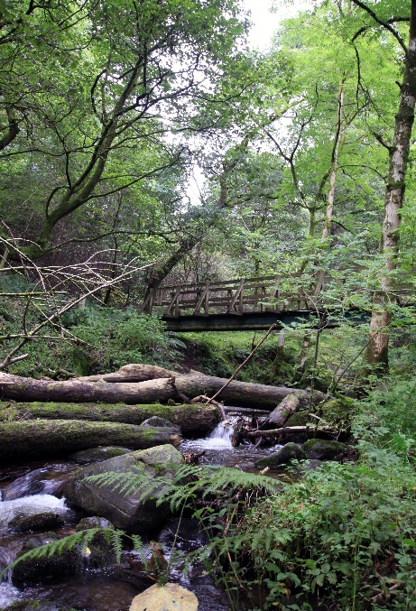
Volunteer Manager:
Helen Costin, Ranger, Dollar Glen

Suggested Time Commitment:
3-5 Hours weekly on Wednesdays

Type of role:
All year round

Why do you need me?

This beautiful stretch of woodland lies east of Stirling and is ensconced in the shadow of the Ochil Hills. There’s a wealth of rare wildlife habitats here, including being a nationally important location for lichens and ferns. Green woodpecker, dipper and nuthatch are three of the many species of birds who live in the lush, wooded gorges.

Over the last few years our path network at Dollar glen has seen higher levels of use than ever before. We need your help to improve and maintain our path network and/or monitor our wildlife. This helps us to ensure a caring and vibrant environment for visitors and wildlife alike.

What’s included in the role?

- To assist the ranger with site maintenance
- To assist the ranger with path maintenance
- To undertake wildlife surveys in the glen
- To be an ambassador to the Trust

Why should I volunteer in this role?

This role is suited to volunteers who love the great outdoors, nature and enjoys practical work; you will need to be physically fit to assist with the path maintenance. There are opportunities to be trained in various aspects of conservation working as part of a team or individually. As a volunteer within the Forth Valley region there may be further opportunities to assist at wider events in the area.

Trust volunteers can attend special events such as training sessions and are recognised for their work through our national ‘thank you’ programmes.

Who will I be working with?

As it is a small team, you’ll be working directly with your Volunteer Manager and a group of other volunteers.

Do I need any previous experience for this role?
In general, you don’t need any specific experience or qualifications to volunteer with us.

For this role, we’re looking for someone who is enthusiastic about the work of the Trust, passionate about its values and objectives, and happy to engage with people of all ages and backgrounds. You’ll be able to provide clear and helpful information to our visitors and ensure they all have a great experience.

We’ll provide an induction and training for you (all about the Trust, its values and your role) to get started, and we’ll help you keep learning while you’re volunteering with us. This includes free access to all of the courses in our online e-learning system.

Who can volunteer with the Trust?
We have an Equality and Diversity policy, and our volunteering opportunities are open to anyone to apply. After you apply, we’ll get in touch to arrange an informal chat with you, to help you understand a bit more about the role and see if it’s right for you.

What if I need some extra help to volunteer?
Most of our volunteer roles are flexible and can be tailored to meet your needs. Our volunteer manager will be happy to discuss any help that you might need to volunteer, including adapting the role or assisting with volunteer expenses, when you first meet up.

Will you carry out any checks before I can start this role?
For this role, we don’t carry out reference checks, and you won’t be required to have a criminal record check if you do not wish to assist with events. If there’s any information you’d like to share with us, you will have the opportunity to do this when completing your application / registration form.

What’s the next step?
You can apply online now for this role through our website application portal. Alternatively, you can pick up a form from reception at the Hive, Park Place, and we will pick up your completed form from there. If you would like help filling out the form, the staff at the Hive will be happy to help during their quieter times.
Contact Helen Costin, Dollar Glen Ranger for more information at hcostin@nts.org.uk or contact her on Facebook Messenger https://www.facebook.com/DollarGlen/

Last Revision Date: 10/04/2024

