Palace Guide – Culross Palace
Volunteer Role Description

Directorate:  Heritage Properties / Edinburgh and East] | 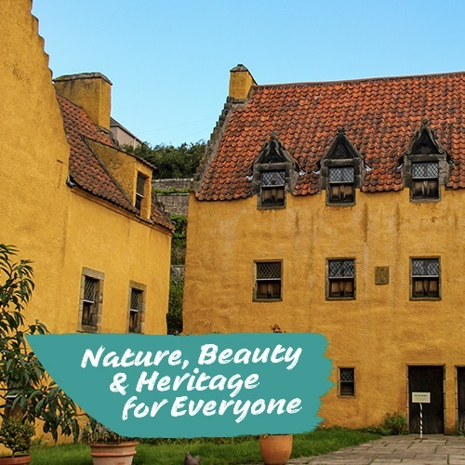
Volunteer Manager:
Elaine Strachan, Visitor Services Manager

Suggested Time Commitment:
The Palace is open daily from 10am to 5pm between 15th March until 31 October
- Full day shift – 9.55 - 16.55
or
- Flexible - to suit the needs of the property and the volunteer
Type of role:
Ongoing

Why do you need me?
Culross Palace is a 17th century scheduled ancient monument which was originally a merchant house. The unique interiors of the Palace feature rare examples of 17th century painted woodwork and it has a warm and welcoming atmosphere. The garden, a hidden gem, is devoted to herbs, trees and vegetables which would have flourished in the early 17th century. Culross is a former seaport on the north shore of the River Forth and traded extensively with the continent and highlights the first development of industrialisation of Scotland.
Today, our volunteers help us to look after this wonderful place and welcome visitors from around the world who come to admire Culross. As the number of visitors to the Royal Burgh increases, largely down to the hit TV show Outlander, we are looking for Guide volunteers to work alongside our existing team of staff and volunteers who welcome visitors and introduce them to the property.

What’s included in the role?
- to greet and welcome all visitors to the property
- maximise visitor enjoyment and their understanding of the property through the presentation of verified facts and anecdotes appropriate to individual’s needs.
- management of visitor flow within the property
- being mindful of the security and conservation needs of the property and its contents, minimising opportunities for theft or damage
- provide general visitor information
- implementing emergency evacuation procedures if required
- Maintaining a safe environment for staff, volunteers and visitors at all times

Full training will be provided for all aspects of the role.

Why should I volunteer in this role?
This role will give you the opportunity to meet visitors from around the world and to share your enthusiasm about Culross Palace and the National Trust for Scotland.
Trust volunteers can attend special events such as training sessions and are recognised for their work through our national ‘thank you’ programmes.
Volunteer cards are available to all active registered volunteers on completion of 40 hours of volunteering and are renewed each March if volunteers continue to actively assist each year. The card provides:-
- Free admission to all National Trust for Scotland properties
- Free admission to all National Trust (England, Wales, and Norther Ireland) properties
- 20% discount on retail purchases in National Trust for Scotland shops
- 20% discount on the rental price on all NTS self-catering holiday accommodation managed by Sykes, our partner organisation, and 10% for other Sykes properties

Who will I be working with?
Generally, you’ll be working with a team of other volunteers and Trust employees. If you need help while volunteering, your volunteer manager or another appointed person will also be around to assist.

Do I need any previous experience for this role?
In general, you don’t need any specific experience or qualifications to volunteer with us.
For this role, we’re looking for someone who is enthusiastic about the work of the Trust, passionate about its values and objectives, and happy to engage with people of all ages and backgrounds. You’ll be able to provide clear and helpful information to our visitors and ensure they all have a great experience.

We’ll provide an induction and training for you (all about the Trust, its values and your role) to get started, and we’ll help you keep learning while you’re volunteering with us. This includes free access to all of the courses in our online e-learning system.

Who can volunteer with the Trust?
We have an Equality and Diversity policy, and our volunteering opportunities are open to anyone to apply. After you apply, we’ll get in touch to arrange an informal chat with you, to help you understand a bit more about the role and see if it’s right for you.

What if I need some extra help to volunteer?
Most of our volunteer roles are flexible and can be tailored to meet your needs. Our volunteer managers will be happy to discuss any help that you might need to volunteer, including adapting the role or assisting with volunteer expenses, when you first meet up.

Will you carry out any checks before I can start this role?
For this role, we don’t carry out reference checks, and you won’t be required to have a criminal record check. If there’s any information you’d like to share with us, you will have the opportunity to do this when completing your application / registration form.

What’s the next step?
You can apply online now for this role through our website application portal.
If you would like some extra information before applying, you can contact Elaine Strachan, Visitor Services Manager on 01383 880 359 or culross@nts.org.uk

Last Revision Date: 15 January 2025

