Retail & Admissions – Mackintosh at the Willow
Volunteer Role Description

Photo of property or volunteer activity

Thank you for your interest in volunteering with the National Trust for Scotland. For more information, or to apply for this role, please contact:

Caitlin Divers
General Manager; Mackintosh at the Willow
cdivers@nts.org.uk
0141 375 9572
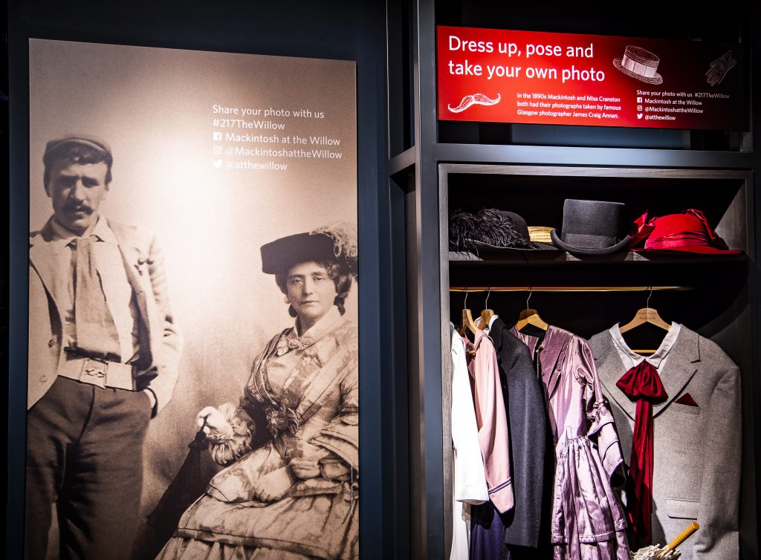

What does this volunteer role involve?

Mackintosh at the Willow is a renowned historical site and tearoom designed by the famous architect Charles Rennie Mackintosh. The visitor attraction offers a unique blend of history, culture, and food and beverage offerings attracting visitors from all over the world.
We are dedicated to preserving the legacy of Mackintosh while providing an exceptional experience for our guests.
As a Retail and Admissions Volunteer, you will play a vital role in ensuring our visitors have a memorable and enjoyable experience. You will assist with various tasks in our retail shop and admissions area, providing excellent customer service and supporting the day-to-day operations.

What you’ll be doing:
- Based in the retail store you’ll welcome guests with a friendly manor, providing them with information about Mackintosh at the Willow and answering any questions they may have.

- Assisting with ticket sales, check-in processes, and provide visitors with essential information about tours, exhibition, creative learning visits & activities happening throughout the venue.

- Support the retail team by dusting and restocking shelves and offering guidance to visitors by answering their questions.

- Customer Service: Assist visitors, ensuring they have a positive and enriching experience. Handle inquiries and resolve any issues efficiently and courteously by communicating with the retail team & management.

- Exhibition: ensuring that the exhibition is kept tidy and reporting any issues to management. Keeping the costumes and areas in good order and answering any questions visitors may have about specific parts of the exhibition and building.

- Helping tour guides in the greeting of tour groups and assisting when it’s busy to help guide them to their meeting points. When appropriate assisting with larger tour groups by answering questions about the building and Mackintosh.

- Event Support: Assist during special events, workshops, and exhibitions, contributing to the overall success of these activities.

- How much time you’ll be giving:

  - Flexible timings: seasonal support required minimum 4 hours per week.
  - We’re open between 9am and 6pm from May-September end.

Do I need any previous experience?
Include either:
You don’t need any specific experience or qualifications to volunteer with us. What you will need to be is:

- A good communicator and have strong verbal communication skills with the ability to interact with diverse groups of people.

- A passion for providing outstanding customer service and creating a welcoming atmosphere.

- Punctual, dependable, and able to commit to a regular volunteer schedule.

- Have an interest in Heritage and Culture!

- Ability to work collaboratively with team members and other volunteers.

- Be comfortable handling a variety of tasks and adapting to changing situations.

We’ll provide an induction and training for you as needed along with support to help you carry out your volunteering role.

Why should I volunteer in this role?
As a National Trust for Scotland volunteer, you will be helping to care for and provide access to amazing places. You may learn new things, develop new skills, make new friends. You will certainly become a valued part of the NTS team. You can find out more about how we recognise the contribution of our volunteers and lots of other useful information, including payment of expenses, in our Volunteer Handbook 2024

What next?
If you would like to apply, please contact the person listed above. We will be in touch to arrange:
- to have an informal chat & arrange a taster session

