Volunteer Ranger Role Description

Directorate:  North East Ranger Service | 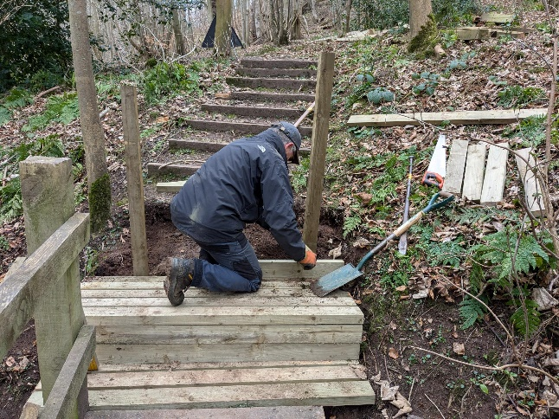
Volunteer Manager:
Lynne McKenzie / Roddy Hamilton / Vivian Bisset
Suggested Time Commitment:
Hours within the normal working day of M-F
9am-5pm. There may be weekend and evening work available on an ad-hoc basis.
Type of role:
Ongoing

Why do you need me?
The Trust's North East Ranger service operates from the North East Regional Office which is headquartered at Crathes Castle. It aims to protect and enhance the biodiversity of our estates, provide safe access and enjoyment for visitors, and offers a varied education programme. The Ranger team is looking for volunteers to assist with managing the countryside element of the Trust’s North East properties.

What’s included in the role?
Based at Crathes Castle and covering nine other NTS properties in the region, you will be involved in practical conservation work with activities ranging from countryside trail and furniture maintenance to wildlife surveys and habitat management.

Why should I volunteer in this role?
Volunteering with the ranger service offers the opportunity to work as part of a team, gain experience and learn new skills. The work is incredibly varied and rewarding. As well as day to day at work training there will be opportunities to participate in a range of training days through the Scottish Countryside Rangers Association (SCRA) which the ranger service helps to run.

Who will I be working with?
Generally, you’ll be working with of other volunteers and Trust employees within the ranger team. You might occasionally be asked to work on your own to carry out estate patrols or tasks while adhering to the NTS lone working procedures and risk assessment. If you need help while volunteering, your volunteer manager or another appointed person will also be around to assist.

Do I need any previous experience for this role?
For this role, we’re looking for someone who is enthusiastic about the work of the
National Trust for Scotland and passionate about our charity’s values and objectives.

While specific experience is not required to apply, the ideal candidate will:
- Have with a keen interest in the environment, wildlife, and countryside management
- Be willing to engage with people of all ages and backgrounds as you will be an ambassador for our charity while volunteering
- Enjoy working outdoors and should be comfortable walking across varied terrain and in all weathers as part of this role
- Have excellent interpersonal skills who wish to gain valuable experience and work with experts in the field
- Possession of a full, clean driving license would be desirable but is not essential

We’ll provide an induction and training for you (all about the Trust, its values and your role) to get started, and we’ll help you keep learning while you’re volunteering with us. This includes free access to all the courses in our online e-learning system.

Who can volunteer with the Trust?
Anyone with the right to live and work in the UK. We have an Equality and Diversity policy, and our volunteering opportunities are open to anyone to apply. After you apply, we’ll be in touch to discuss further details of the role.

What if I need some extra help to volunteer?
Volunteer for the Trust and need think you may need extra help contact the People team at askpea@nts.org.uk to discuss in the first instance. Most of our volunteer roles are flexible and can be tailored to meet your needs. Our volunteer managers will be happy to discuss any help that you might need to volunteer, including adapting the role or assisting with volunteer expenses.

Will you carry out any checks before I can start this role?
As the role potentially involves working with children, we may need to carry out a criminal records check before you start – in this case, a Protection of Vulnerable Groups check.

What’s the next step?
You can apply online now for this role by completing the attached registration form and returning to NERangerService@nts.org.uk.

If you would like some extra information before applying, you can contact 01330 844810 or NERangerService@nts.org.uk.

Last Revision Date: [04/08/2025]

