The Tenement House – Volunteer Guide
Volunteer Role Description

Directorate:  Built Heritage – South & West (Glasgow) | 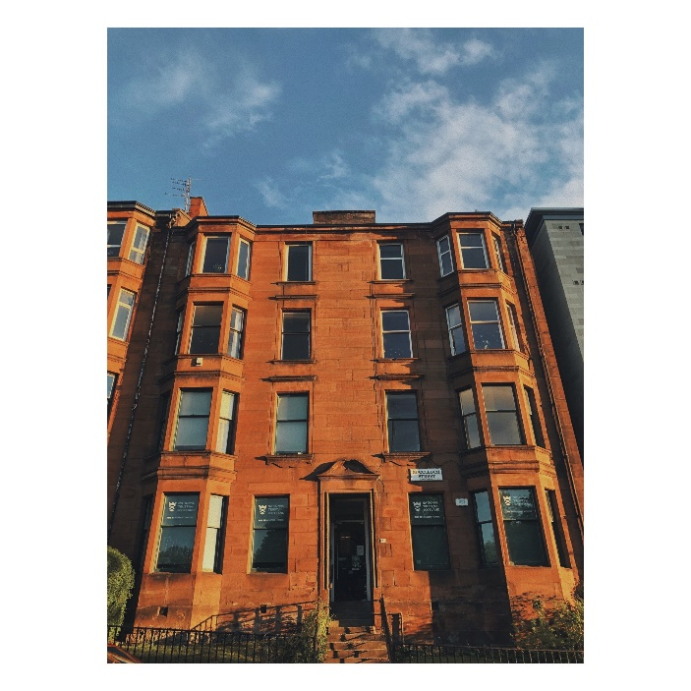
Volunteer Manager:
Rachel Campbell
Visitor Services Supervisor Tenement House, Holmwood House & Weavers Cottage
Suggested Time Commitment:
Shifts available on every day of the week,
agreed days / times.
Morning shift: 10:00- 13:30
Afternoon shift: 13:30- 17:00
You can volunteer once a week or once a fortnight.
Type of role:
Ongoing

Why do you need me?
The Tenement House welcomes over 26,000 visitors every year from all over the world to learn all about Glasgow’s past, woman’s history and architecture and design.
We are looking for enthusiastic volunteers to get involved with visitor engagement at the property. Volunteers help to bring the Tenement House to life by talking to visitors and guiding them through the rooms. They are also part of sharing information about the National Trust for Scotland’s valuable conservation work throughout their visit. This is a rare and exciting opportunity to get involved in a beautiful property and be a part of a fantastic team!

What’s included in the role?
- Learning about the Tenement House, our collections and how / why we care for them
- Engaging with our visitors to explain our conservation work
- Delivering excellent customer service to our visitors

Why should I volunteer in this role?
This is a wonderful opportunity to gain practical experience of guiding and front of house in a heritage environment, and to see behind the scenes and learn new skills. The Tenement House is a beautiful property, with a friendly team of volunteers and staff. We are looking to engage more visitors and to share our love of Glasgow’s past with everyone. Volunteers can also get involved in other activities as available at the property. Trust volunteers can attend special events such as training sessions and are recognised for their work through our national thank you programmes.

Who will I be working with?
Depending upon the activity, you may be working within a small team of volunteers, or you may be working directly with your volunteer manager and other members of the team. If you need help while volunteering, your volunteer manager or another appointed person will also be around to assist.

Do I need any previous experience for this role?
In general, you don’t need any specific experience or qualifications to volunteer with us but an interest in conservation is preferable.
For this role, we’re looking for someone who is enthusiastic about the work of the Trust, passionate about its values and objectives, and happy to engage with people of all ages and backgrounds to provide helpful information and ensure our visitors have a great experience. In particular, you’ll be happy to work well in a small team and carry out tasks in front of our visitors; as the role involves talking and interacting with them, it’s important you can follow direction and use the correct methods and procedures for different tasks.

We’ll provide an induction and training for you (all about the Trust, its values and your role) to get started, and we’ll help you keep learning while you’re volunteering with us including providing free access to the courses in our online e-learning system.

Who can volunteer with the Trust?
We have an Equality and Diversity policy, and our volunteering opportunities are open to anyone. After you apply, we’ll get in touch to arrange an informal chat with you, to help you understand a bit more about the role and see if it’s right for you.
Whether you’re a heritage or fine art student, someone with an interest in museums and historic properties, architecture or design, or just looking for the chance to see what goes on behind the scenes, this could be the role for you!

What if I need some extra help to volunteer?
Most of our volunteer roles are flexible and can be tailored to meet your needs. Our volunteer managers will be happy to discuss any help that you might need to volunteer when you first meet up.

Will you carry out any checks before I can start this role?
For this role, we don’t carry out reference checks, and you won’t be required to have a criminal record check. If there’s any information you’d like to share with us, you will have the opportunity to do this when completing your application / registration form.

What’s the next step?
You can apply online now for this role through our website application portal or fill out a paper form available at the front desk.
If you would like some extra information before applying, you can contact us at tenementhouse@nts.org.uk

Last Revision Date: 01/08/2025

