Outdoor Conservation Volunteer Role Description

Directorate:  Operations / North East /  North East Ranger Service | 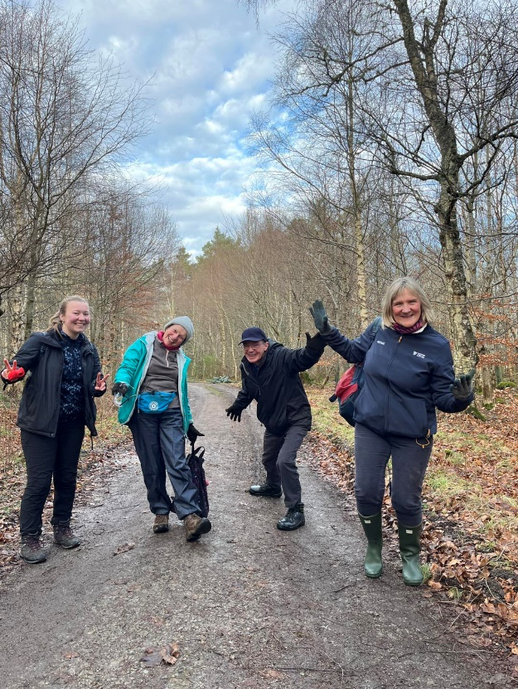
Volunteer Manager:
Roddy Hamilton / Lynne McKenzie / Vivian Bisset
Suggested Time Commitment:
Ad hoc – work parties are typically held once per month at a property in Aberdeenshire
Type of role:
Ongoing

Volunteer role description
Working directly and being lined managed by our North East Ranger team, you will be responsible for carrying out tasks that help us achieve the maximum potential for our charity to meet its strategic objectives around environmental and conservation outdoor work for the Trust and the heritage we are tasked to look after and care for.

An Outdoor Conservation Volunteer is someone who offers their time at properties in Aberdeenshire to help undertake tasks that help care and protect the environment and countryside access for our communities and visitors, under the supervision of a staff member either within the ranger team or a property team, such as a gardener.

Volunteers are an integral part of the National Trust for Scotland, bringing enthusiasm, experience, skills and knowledge as part of the Trust team. So, whether you are just starting out on your volunteering journey or returning to volunteering and outdoor conservation volunteering is something you are interested in please complete the Volunteering application form and return to the NE Ranger Service at NERangerService@nts.org.uk .

What’s included in the role?
- Practical conservation tasks such as path maintenance and repair, fencing, habitat work, invasive species removal
- General environmental improvement works i.e. garden maintenance including weeding, mulching, planting, leaf clearing, edging, cutting back, pruning and other regular, seasonal gardening tasks
- Learning new skills and working within a small team
- Opportunity for involvement in new conservation projects and events
- Welcoming visitors/members and helping them to enjoy their visit to the properties.
- Supporting set up and tidy up at property events

Why should I volunteer in this role?
Volunteering is one of the main ways that anyone can participate across the Trust. Outdoor Conservation Volunteers have a deep commitment to protecting Scotland’s heritage and often volunteer to be proactive in helping to protect our environment, habitats and species, and contribute to the ongoing provision of safe and enjoyable countryside access for all.

In the specific role of Outdoor Conservation Volunteer the practical nature of the work is a great way to be physically active; while working with team members and being part of the ‘community’ of volunteers and Trust teams has helped volunteers experience an improved sense of well-being and mental health. Many outdoor Conservation Volunteers have also enjoyed learning new skills and about conservation roles and activities before heading off into further education to study conservation and nature subjects.

Who will I be working with?
Generally, you’ll be working as part of a team with other outdoor conservation volunteers and Trust employees.

What do I need for this role?
You don’t need any specific experience or qualifications to volunteer with us.

For this role, we’re looking for someone who is enthusiastic about the work of the Trust, passionate about its values and objectives, and who is happy to engage with people of all ages and backgrounds in a positive and respectful manner. All should welcome collaborative working and be willing to follow guidance and instruction from Trust staff.

We’ll provide an induction and training for you (all about the Trust, its values and your role) to get started, as well as training on tool use for all equipment used and safety considerations. We also seek to inform our volunteers of the reasoning behind our conservation projects or the tasks being carried out.

Please note planning transport to property where work party is being held is responsibility of volunteer to arrange. We support volunteer autonomy in deciding how often they can commit to dates of planned work parties and where they are willing to travel to.

Once registered as an NTS volunteer you will also have free access to all of the courses in our online e-learning system.

Who can volunteer with the Trust?
Outdoor Conservation Volunteer roles are open to anyone with the right to live and work in the UK, however, we may have to ‘objectively justify’ some tasks under the Equality Act 2010, this means some of our volunteer tasks may not be suitable for people with impairments, if this is the case we will make the volunteer aware of this to ensure the health, safety and well-being of the volunteer is put first.
What if I need some extra help to volunteer?
Volunteer for the Trust and need think you may need extra help contact the People team at askpea@nts.org.uk to discuss in the first instance. Most of our volunteer roles are flexible and can be tailored to meet your needs. Our volunteer managers will be happy to discuss any help that you might need to volunteer, including adapting the role or assisting with volunteer expenses.

Will you carry out any checks before I can start this role?
There are no checks required as part of this role.

What’s the next step?
You can apply online now for this role by completing the attached registration form and returning to NERangerService@nts.org.uk

If you would like some extra information before applying, you can contact 01330 844810 or NERangerService@nts.org.uk

Data Protection
The National Trust for Scotland, as a data controller, is committed to protecting your personal data. We will process the personal data provided on this form for the purposes of recording your decision about continuing to volunteer with the Trust. For further information about how we process personal data please see www.nts.org.uk/privacy-data-protection

