Newhailes - Room Guide
Volunteer Role Description

Directorate:  Operations / Edinburgh and East | 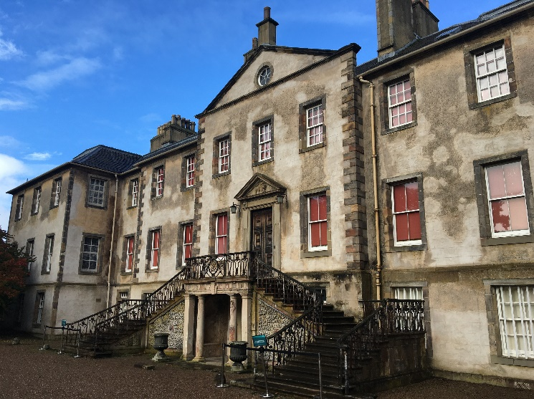
Volunteer Manager:
Visitor Services Manager
Suggested Time Commitment:
4 hours per month
Last Sunday of every month 11a.m. to 3 p.m.
Type of role:
Ongoing role – no defined end date
Why do you need me?
Passionate about history and heritage? Interested in sharing tales with people from all over the world? This could be the perfect opportunity for you! We need your help to peel back the layers of more than 300 years of history and bring to life the stories of the house, and the people who lived there in a fun and engaging way.
Newhailes is a 17th century Palladian Mansion located just outside Edinburgh, once home to the influential Dalrymple family. The family extended the house, and added fine collections of paintings, ceramics and furniture, as well as landscaping the grounds surrounding the house. It remained in the family for nearly 300 years before an increasing burden of taxation, repairs and maintenance saw the house decline in the 20th century. The NTS acquired the property in 1997, preventing the further decline of the property and dispersal of the contents of the house.
What’s included in the role?
- Welcoming visitors and helping them to enjoy their visit
- Explaining and interpreting the house and encouraging visitors to engage with the collections and the stories they tell
- Answering questions
- Acting as an ambassador to the NTS
Why should I volunteer in this role?
This role will give you the opportunity to meet people from around the world and help them learn about the history of Newhailes. You will be provided with full training, and will be part of the team that re-opens Newhailes to the public. Volunteers at Newhailes can get involved in other opportunities such as research. Trust volunteers can attend special events such as training sessions and are recognised for their work through our national thank you programmes.
Who will I be working with?
You will be working with a team of other volunteers and Trust employees. If you need help while volunteering, your volunteer manager or another appointed person will also be around to assist.
Do I need any previous experience for this role?
In general, you don’t need any specific experience or qualifications to volunteer with us.
For this role, we’re looking for someone who is enthusiastic about the work of the Trust, passionate about its values and objectives, and is happy to engage with people of all ages and background. You’ll be able to provide clear and helpful information to our visitors, conveying your interest and enthusiasm for Newhailes and its history to a wide variety of people.
We’ll provide an induction and training for you (all about the Trust, its values and your role) to get started, and we’ll also provide training sessions to help you deliver your tours. You’ll also have free access to all of the courses in our online e-learning system.
Who can volunteer with the Trust?
We have an Equality and Diversity policy, and our volunteering opportunities are open to anyone to apply. After you apply, we’ll get in touch to arrange an informal chat with you, to help you understand a bit more about the role and see if it’s right for you.
What if I need some extra help to volunteer?
Most of our volunteer roles are flexible and can be tailored to meet your needs, although due to the shift pattern for this role, here we’re looking for volunteers who are regularly available at specific times. Our volunteer managers will be happy to discuss any help that you might need to volunteer, including adapting the role or assisting with volunteer expenses, when you first meet up.
Will you carry out any checks before I can start this role?
For this role, we don’t carry out reference checks, and you won’t be required to have a criminal record check. If there’s any information you’d like to share with us, you will have the opportunity to do this when completing your application / registration form.
What’s the next step?
You can apply online now for this role through our website application portal.
If you would like some extra information before applying, you can contact Anna Brereton, on 07869 083 209 or at abrereton@nts.org.uk
Last Revision Date: 06/12/2022

