Creative Learning Volunteer, Weekend Workshops
Mackintosh at the Willow

Volunteer Role Description

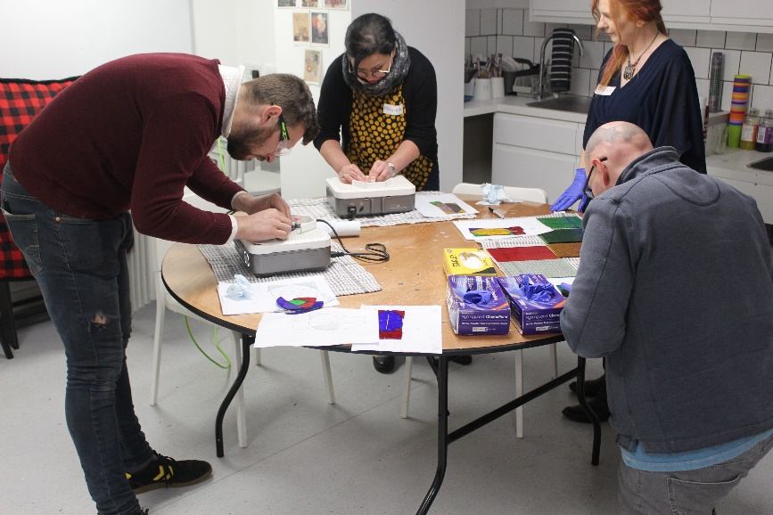

Thank you for your interest in volunteering with the National Trust for Scotland. For more information, or to apply for this role, please contact:

Oliver Braid, Creative Learning Manager / obraid@nts.org.uk / 0141 332 7696

What does this volunteer role involve?

The Creative Learning team at Mackintosh at the Willow offer learning experiences for community groups, schools, colleges, and universities, alongside out-of-school care and family activities during holiday periods. In this role you’ll be supporting our weekend workshops and talks for adults, including leading guided tours of our heritage building, welcoming guests, assisting freelance artists to run varied creative workshops and providing simple tech support to invited speakers.
You will need to be available for this role once a month on Saturdays and/or Sundays. Each workshop lasts for approximately 6 hours, each talk lasts for approximately 4 hours
You may also have the opportunity to contribute to our blogs or social updates.
You will be supported by our friendly and enthusiastic Creative Learning and Education Team who will provide you with an induction and training as needed, along with guidance to help you carry out your volunteering role.
Do I need any previous experience?

You don’t need any specific experience or qualifications to volunteer with us. What you will need to be is:
- Enthusiastic about the work of the Trust
- Happy to talk to the public and confident in facilitating group sessions
- A good team player, willing to help with what needs doing
- Willing to develop your knowledge of Charles Rennie Mackintosh, Kate Cranston and Mackintosh at the Willow.
- Willing to undergo training as necessary to volunteer with National Trust for Scotland
- Willing to undertake a criminal records/PVG check

Why should I volunteer in this role?
As a National Trust for Scotland volunteer, you will be helping to care for and provide access to amazing places. You may learn new things, develop new skills, make new friends. You will certainly become a valued part of the NTS team. You can find out more about how we recognise the contribution of our volunteers and lots of other useful information, including payment of expenses, in our Volunteer Handbook 2024

What next?
If you would like to apply, please contact the person listed above. We will be in touch to arrange an informal chat, followed by a taster session if applicable.

Last Revision Date: June 2024

