Leith Hall – Guide
Volunteer Role Description

Directorate:  Operations / North East | 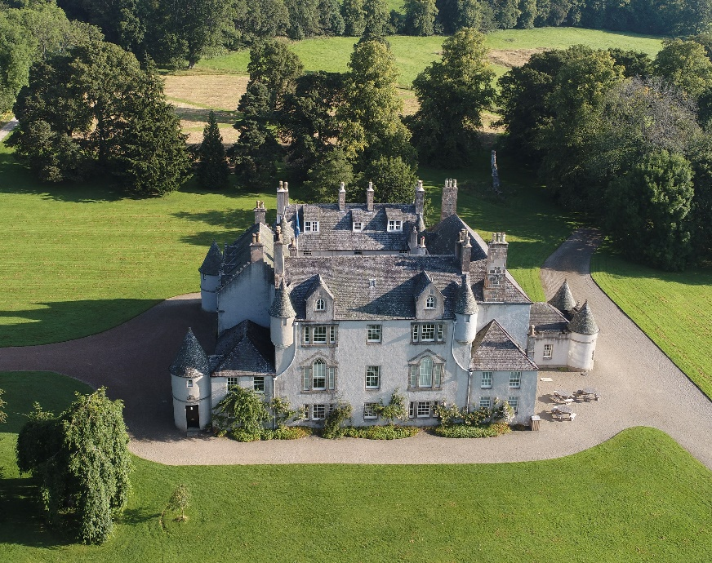
Volunteer Manager:
Visitor Services Supervisor - Operations
Suggested Time Commitment:
One day per week
Shift basis – regular agreed day and times
Type of role:
Ongoing role – no defined end date
Property Open – April - October
Why do you need me?

The building of Leith Hall began in 1650, took three centuries to complete and remained the home of the Leith-Hay family until the mid-20th century. This military family was connected to many famous campaigns around the world, including Culloden, the storming of San Sebastian during the Napoleonic Peninsular War, and the Crimean War.
The rest of the house contains one of the Trust’s most important and complete collections, the family having left their furniture and paintings to the Trust. The hall has a fine collection of artefacts from throughout the hall’s history and architecturally the hall has an interesting story. Leith Hall has something for all interests with lots to explore and learn about to share with the visitors.
Leith Hall is situated on an estate with woodland walks and ponds and a wonderful walled garden with a recently re-established rockery and a productive kitchen garden.
What’s included in the role?
- Welcoming visitors and helping them to enjoy their visit
- Taking visitors (up to 13 people) on tours of Leith Hall, both inside and outside.
- Acting as an ambassador to the NTS

Why should I volunteer in this role?
This role will give you the opportunity to meet people from around the world and help them learn about the history of Leith Hall. You will be provided with full training, and will be part of the team that re-opens Leith Hall to the public. Volunteers at Leith Hall can get involved in other opportunities such as research and care of the collection. Trust volunteers can attend special events such as training sessions and are recognised for their work through our national thank you programmes.
Who will I be working with?
You will be working with a team of other volunteers and Trust employees. If you need help while volunteering, your volunteer manager or another appointed person will also be around to assist.
Do I need any previous experience for this role?
In general, you don’t need any specific experience or qualifications to volunteer with us.
For this role, we’re looking for someone who is enthusiastic about the work of the Trust, passionate about its values and objectives, and is happy to engage with people of all ages and background. You’ll be able to provide clear and helpful information to our visitors, conveying your interest and enthusiasm for Leith Hall and its history to a wide variety of people.
We’ll provide an induction and training for you (all about the Trust, its values and your role) to get started, and we’ll also provide training sessions to help you deliver your tours. You’ll also have free access to all of the courses in our online e-learning system.
Who can volunteer with the Trust?
We have an Equality and Diversity policy, and our volunteering opportunities are open to anyone to apply. After you apply, we’ll get in touch to arrange an informal chat with you, to help you understand a bit more about the role and see if it’s right for you.
What if I need some extra help to volunteer?
Most of our volunteer roles are flexible and can be tailored to meet your needs. Our volunteer managers will be happy to discuss any help that you might need to volunteer, including adapting the role or assisting with volunteer expenses, when you first meet up.
Will you carry out any checks before I can start this role?
For this role, we don’t carry out reference checks, and you won’t be required to have a criminal record check. If there’s any information you’d like to share with us, you will have the opportunity to do this when completing your application / registration form.
What’s the next step?
You can apply online now for this role through our website application portal.
If you would like some extra information before applying, you can contact Beatrice Fettes-Leagas via leithhall@nts.org.uk

