Kellie Castle - Guide
Volunteer Role Description

Directorate:  Operations / Edinburgh and East | 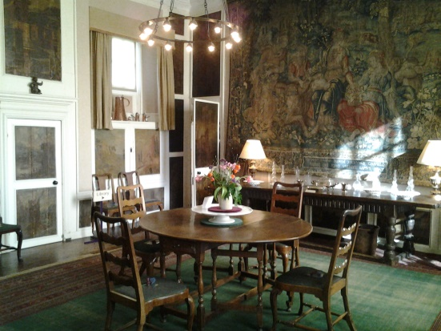
Volunteer Manager:
Fiona Austin, Visitor Services Supervisor
Suggested Time Commitment:
Flexible (within opening hours) to meet the needs of the property and volunteer
Open April – November
Type of role:
Ongoing role – no defined end date

Why do you need me?
First built in the 14th century, Kellie Castle has been extended and added to over the centuries, and today features magnificent interior decoration from the 19th century, including a long-hidden Arts and Crafts mural by Phoebe Anna Traquair. Our volunteers help us look after this wonderful building, welcome visitors from around the world and ensure that they have a fantastic experience while visiting. Our volunteer guides explain the castle’s long history to our visitors, and help them understand more about the families who lived here and the collections on display.

What’s included in the role?
- Welcoming visitors and helping them to enjoy their visit
- Explaining and interpreting the castle and collections
- Ensuring that the property and its contents are respected and secure
- Ensuring the people working and visiting the property remain safe at all times

Why should I volunteer in this role?
This role will give you the opportunity to meet people from around the world and help them learn about the history of the property, its historical context and those who lived here. Volunteers at Kellie Castle can also get involved in other opportunities which arise from time to time. Trust volunteers can attend special events such as training sessions and are recognised for their work through our national ‘thank you’ programmes. Upon completing 40 hours of volunteering per year volunteers are eligible for an annual NTS pass for themselves and a family member.
Who will I be working with?
Generally, you’ll be working with a team of other volunteers and Trust employees, and as you’ll usually volunteer on a specific shift, you’ll see the same volunteer team on a regular basis. If you need help while volunteering, your volunteer manager or another appointed person will also be around to assist.

Do I need any previous experience for this role?
In general, you don’t need any specific experience or qualifications to volunteer with us.
For this role, we’re looking for someone who is enthusiastic about the work of the Trust, passionate about its values and objectives, and happy to engage with people of all ages and background. You’ll be able to provide clear and helpful information to our visitors, conveying your interest and enthusiasm for the castle and its history to a wide variety of people.

We’ll provide an induction and training for you (all about the Trust, its values and your role) to get started, and we’ll help you to keep learning while you’re volunteering with us. You’ll also have free access to all of the courses in our online e-learning system.

Who can volunteer with the Trust?
We have an Equality and Diversity policy, and our volunteering opportunities are open to anyone to apply. After you apply, we’ll get in touch to arrange an informal chat with you, to help you understand a bit more about the role and see if it’s right for you.

What if I need some extra help to volunteer?
Most of our volunteer roles are flexible and can be tailored to meet your needs, although due to the shift pattern for this role, here we’re looking for volunteers who are regularly available at specific times. Our volunteer managers will be happy to discuss any help that you might need to volunteer, including adapting the role or assisting with volunteer expenses, when you first meet up.

Will you carry out any checks before I can start this role?
For this role, we don’t carry out reference checks, and you won’t be required to have a criminal record check. If there’s any information you’d like to share with us, you will have the opportunity to do this when completing your application / registration form.

What’s the next step?
You can apply online now for this role through our website application portal.
If you would like some extra information before applying, you can contact Fiona Austin, Visitor Services Supervisor, on 01333 720271 or faustin@nts.org.uk

Last Revision Date: 26th January 2023

