**Cottage/Museum Guide – Hugh Miller’s Birthplace**

**Volunteer Role Description**

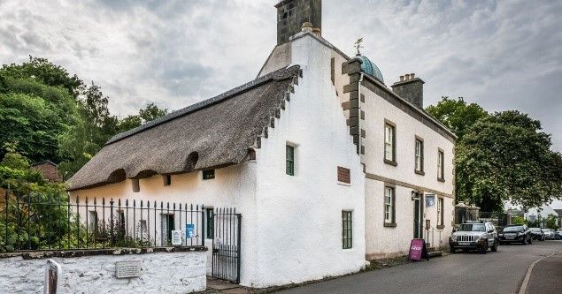

Thank you for your interest in volunteering with the National Trust for Scotland. For more information, or to apply for this role, please contact:

*James Ryan (Visitor Services Assistant) -* [*jryan@nts.org.uk*](mailto:jryan@nts.org.uk)*, 01381 600 245 (Wed-Sat)*

*or*

*Debbie Reid (Visitor Services Manager) -* [*dreid@nts.org.uk*](mailto:dreid@nts.org.uk)*, 01381 600 245 (Thurs-Mon)*

**What does this volunteer role involve?**

This role involves working with the front-of-house team in welcoming people to our property and engage with visitors throughout the buildings about the stories surrounding the property, people, and the collection. There will also be opportunities to assist on guided tours and other special events.

Full training and mentoring from experienced staff relating to the history of Hugh Miller, the cottage and building, and the collection will be provided. You can choose to work across either one or both of the buildings and will be provided with resources to help you learn the ins and outs of the property.

Our volunteer roles are fully flexible and can be tailored to meet your needs: our museum and cottage opening times are 11:00 to 16:00 (with the property’s last entry being 15:30) and you can volunteer as little or as long as you like during our opening times.

Volunteers will be provided with branded National Trust for Scotland uniform and will be able to claim expenses on their travel to the property.

**Do I need any previous experience?**

All our roles require no previous experience. An interest in Hugh Miller or the subjects relating to him and his work, a willingness to learn, and being able to work as part of a team is all you need.

We’ll provide an induction and training for you (all about the Trust, its values and your role) to get started, and we’ll help you keep learning while you’re volunteering with us. This includes free access to all of the courses in our online e-learning system, with the potential to undertake further training.

**Why should I volunteer in this role?**

If you have an interest in historical buildings and gardens, or in natural history, the Trust or Hugh Miller, or you’re looking for customer-facing experience in the museum/heritage industry, then this role could be perfect for you.

As a National Trust for Scotland volunteer, you will be helping to care for and provide access to amazing places. You may learn new things, develop new skills, make new friends. You will certainly become a valued part of the NTS team. You can find out more about how we recognise the contribution of our volunteers and lots of other useful information, including payment of expenses, in our [Volunteer Handbook 2024](https://ntswebstorage01.blob.core.windows.net/nts-web-assets-production/downloads/Volunteer-Handbook-2024.pdf).

**What next?**

If you would like to apply, please contact either James or Debbie. One of them will be in touch to arrange to have an informal chat to ensure all parties think this role is perfect for you, as well as arrange a taster session and tour of the property.

We look forward to hearing from you!

**Last Revision Date**: July 2024