Hill of Tarvit - Room Guide
Volunteer Role Description

Directorate:  Operations / Edinburgh and East | 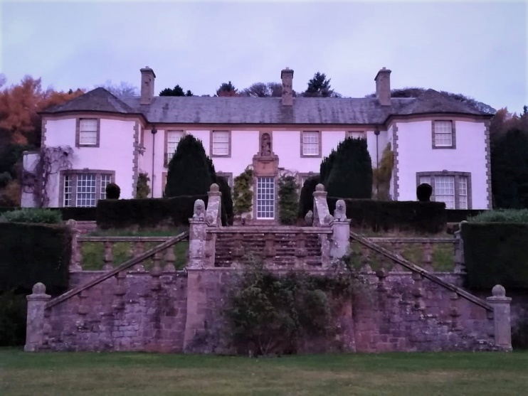
Volunteer Manager:
Visitor Services Supervisor
Suggested Time Commitment:
6 hours per week
Fri or Sat or Sun from 11 am – 5 pm
Type of role:
Seasonal (March to October)
Why do you need me?
Are you passionate about history and heritage? Are you interested in sharing tales with people from all over the world? This could be the perfect opportunity for you! We need your help to bring to life the stories of the Mansion House and the people who lived here in a fun and engaging way.
Hill of Tarvit is an Edwardian Mansion House designed around a collection of artwork and antiques by Sir Robert Lorimer. Despite being built primarily as a treasure chest, the Mansion was also designed on a scale intimate enough to be a comfortable and charming family home for businessman Frederick Sharp, his wife Beatrice, his son Hugh, and his daughter Elisabeth. And it was daughter Elisabeth who bequeathed it to the National Trust for Scotland.
What’s included in the role?
- Welcoming visitors and helping them to enjoy their visit
- Offer information about the room, its content and the story of the family who lived here. You will be supplied with this information – we do not expect our volunteers to be experts on the paintings or furniture!
- Acting as an ambassador to the NTS
Why should I volunteer in this role?
At Hill of Tarvit you will be surrounded by a fine collection of artwork and antiques in an idyllic country-house setting. The role is varied and dynamic as you will meet visitors of all ages and backgrounds and, rather than working from a fixed script, you will adapt what you choose to say accordingly.

Trust volunteers can attend special events such as training sessions and are recognised for their work through our national thank you programmes.
With whom will I be working?
You will be joining a friendly team of volunteers who enthuse at every opportunity to share their knowledge and experience. If you need help while volunteering, your volunteer manager or another appointed person will be around to assist you.
Do I need any previous experience for this role?
In general, you don’t need any specific experience or qualifications to volunteer with us.
For this role, we’re looking for someone who is enthusiastic about the work of the Trust, passionate about its values and objectives, and is happy to engage with people of all ages and background. You’ll be able to provide clear and helpful information and ensure that all our visitors have a great experience.
We’ll provide an induction and training for you (all about the Trust, its values, and your role) to get started, and we’ll also provide training sessions to help you deliver your tours. You’ll also have free access to all of the courses in our online e-learning system.
You will be supplied with all the information you need about the history of the house, the family who lived here and the pieces in the collection.
Who can volunteer with the Trust?
We have an Equality and Diversity policy, and our volunteering opportunities are open to anyone to apply. After you apply, we’ll get in touch to arrange an informal chat with you, to help you understand a bit more about the role and see if it’s right for you.
What if I need some extra help to volunteer?
Most of our volunteer roles are flexible and can be tailored to meet your needs, we are looking for volunteers who are regularly available at specific times. Our volunteer manager will be happy to discuss any help that you might need to volunteer, including adapting the role or assisting with volunteer expenses, when you first meet up.
Will you carry out any checks before I can start this role?
For this role, we don’t carry out reference checks, and you won’t be required to have a criminal record check. If there’s any information you’d like to share with us, you will have the opportunity to do this when completing your application / registration form.
What’s the next step?
You can apply online now for this role through our website application portal.
If you would like some extra information before applying, you can contact Claudia Noble-Pyott, on 07751 938 928 or at cnpyott@nts.org.uk

Last Revision Date: 25/01/2023

