Hill of Tarvit – Garden Volunteer
Volunteer Role Description

Directorate:  Operations / Edinburgh and East | 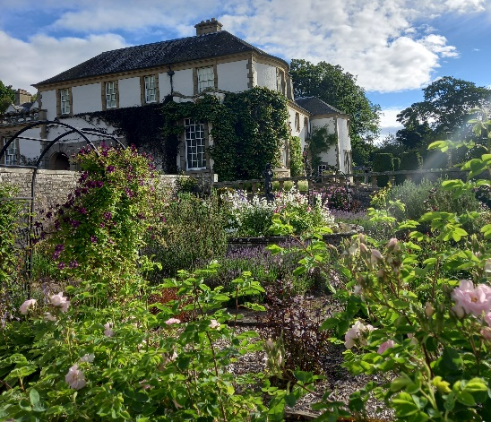
Volunteer Manager:
Head Gardener Mark Armour
Suggested Time Commitment:
6 hours per week
Type of role:
Ongoing – no defined end date

Why do you need me?
Are you passionate about gardening? Are you interested in working in a unique garden originally designed by Sir Robert Lorimer? This could be the perfect opportunity for you!
The gardens on the south side of the mansion at Hill of Tarvit were planned by Lorimer with as wholehearted dedication as the house itself. His aim was to enfold the façade of the house in a totally green setting, keeping colour away from the frontage. On the south side Lorimer created a magnificent sweep of long terraces with manicured lawns on several levels. The original sunken rose garden – Lorimer delighted in designing hidden gardens – on one side of the upper terrace was invisible from the main approach to the house.
What’s included in the role?
- Supporting projects and developments in the garden – anything from planting, pruning, cataloguing seeds, establishing boundaries to answering visitors’ questions
- Acting as an ambassador to the NTS
Why should I volunteer in this role?
‘A garden is a sort of sanctuary, a chamber roofed by heaven: in the garden something of the golden age still lingers.’ ~ Robert Lorimer
We have lots of exciting plans and developments for 2023 and would love you be involved. Our volunteers have the opportunity to make connections with new people, grow confidence and gain a real sense of achievement whilst learning new skills.
Trust volunteers can attend special events such as training sessions and are recognised for their work through our national thank you programmes.
With whom will I be working?
You will be joining a friendly team who enthuse to share their knowledge and experience. If you need help while volunteering, your volunteer manager or another appointed person will be around to assist you.
Do I need any previous experience for this role?
In general, you don’t need any specific experience or qualifications to volunteer with us.
For this role, we’re looking for someone who is enthusiastic about the work of the Trust, passionate about its values and objectives, and is happy to get stuck in.
We’ll provide an induction and training for you (all about the Trust, its values, and your role) to get started. You’ll also have free access to all the courses in our online e-learning system.
Who can volunteer with the Trust?
We have an Equality and Diversity policy, and our volunteering opportunities are open to anyone to apply. After you apply, we’ll get in touch to arrange an informal chat with you, to help you understand a bit more about the role and see if it’s right for you.
What if I need some extra help to volunteer?
Most of our volunteer roles are flexible and can be tailored to meet your needs, we are looking for volunteers who are regularly available at specific times. Our volunteer manager will be happy to discuss any help that you might need to volunteer, including adapting the role or assisting with volunteer expenses, when you first meet up.
Will you carry out any checks before I can start this role?
For this role, we don’t carry out reference checks, and you won’t be required to have a criminal record check. If there is any information you would like to share with us, you will have the opportunity to do this when completing your application / registration form.
What’s the next step?
You can apply online now for this role through our website application portal.
If you would like some extra information before applying, you can contact Mark Armour on 07518 912246 or marmour@nts.org.uk

Last Revision Date: 25/01/2023

