Haddo House - Room Steward
Volunteer Role Description

Directorate:  Operations / North East | 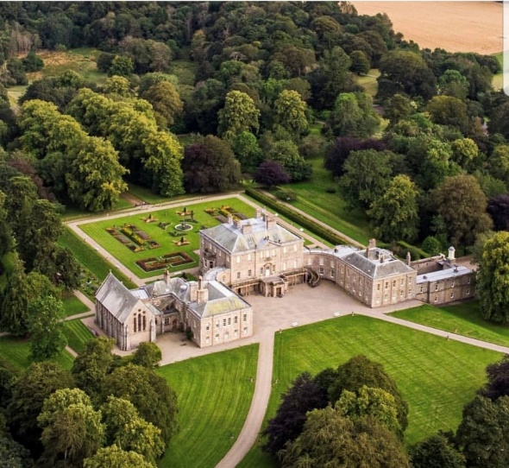
Volunteer Manager:
Visitor Services Supervisor
Suggested Time Commitment:
5 hours per week
Sun from 11 am – 4 pm
Type of role:
Ongoing – no end date

Why do you need me?
Are you passionate about history and heritage? Are you interested in sharing tales with people from all over the world? This could be the perfect opportunity for you! We need your help to bring to life the stories of the Mansion House and the people who lived here in a fun and engaging way.
Stately and striking, Haddo House casts a huge impression from the moment you set eyes on it. Designed in 1732 by William Adam, the house underwent an opulent remodelling in the 1880s. As a result, it has the clean elegance and swooping lines of the Georgian style with a luxurious Victorian interior.
Family portraits trace generations of Gordons, who played a huge part in Scottish history. George Gordon, 1st Earl of Aberdeen was Lord Chancellor of Scotland; the 4th Earl served as Prime Minister. More recently, Haddo was a maternity hospital during World War II – over 1,200 babies were born here.
The house is surrounded by a terrace garden with a lavish herbaceous border and geometric flower beds. A magnificent avenue of lime trees leads to Haddo Country Park.

What’s included in the role?
- Welcoming visitors and helping them to enjoy their visit
- Offer information about the room, its content and the story of the family who lived here. You will be supplied with this information – we do not expect our volunteers to be experts on the paintings or furniture!
- Answering visitor enquiries.
- Working as part of a team.
- Opportunity to assist with guided tours.
- Acting as an ambassador to the NTS
Why should I volunteer in this role?
This role will give you the opportunity to meet people from around the world and help them learn about the history of Haddo House. You will be provided with full training, and will be part of the Haddo House team. Volunteers at Haddo House can get involved in other opportunities such as research. Trust volunteers can attend special events such as training sessions and are recognised for their work through our national thank you programmes.

Trust volunteers can attend special events such as training sessions and are recognised for their work through our national thank you programmes.
With whom will I be working?
You will be joining a friendly team of volunteers who enthuse at every opportunity to share their knowledge and experience. If you need help while volunteering, your volunteer manager or another appointed person will be around to assist you.
Do I need any previous experience for this role?
In general, you don’t need any specific experience or qualifications to volunteer with us.
For this role, we’re looking for someone who is enthusiastic about the work of the Trust, passionate about its values and objectives, and is happy to engage with people of all ages and background. You’ll be able to provide clear and helpful information and ensure that all our visitors have a great experience.
We’ll provide an induction and training for you (all about the Trust, its values, and your role) to get started, and we’ll also provide training sessions to help you deliver your tours. You’ll also have free access to all of the courses in our online e-learning system.
You will be supplied with all the information you need about the history of the house, the family who lived here and the pieces in the collection.
Who can volunteer with the Trust?
We have an Equality and Diversity policy, and our volunteering opportunities are open to anyone to apply. After you apply, we’ll get in touch to arrange an informal chat with you, to help you understand a bit more about the role and see if it’s right for you.
What if I need some extra help to volunteer?
Most of our volunteer roles are flexible and can be tailored to meet your needs, we are looking for volunteers who are regularly available at specific times. Our volunteer manager will be happy to discuss any help that you might need to volunteer, including adapting the role or assisting with volunteer expenses, when you first meet up.
Will you carry out any checks before I can start this role?
For this role, we don’t carry out reference checks, and you won’t be required to have a criminal record check. If there’s any information you’d like to share with us, you will have the opportunity to do this when completing your application / registration form.
What’s the next step?
You can apply online now for this role through our website application portal.
If you would like some extra information before applying, you can contact Claire Russell, on 01651 851440 or at haddohouse@nts.org.uk

Last Revision Date: 01/02/2024

