Guide – Haddo House
Volunteer Role Description

Directorate:  Operations / North East | 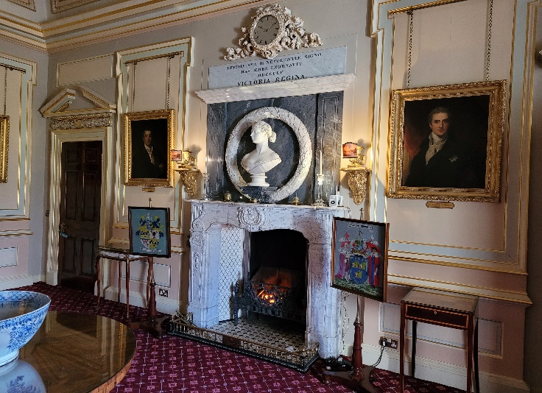
Volunteer Manager:
Visitor Services Supervisor

Suggested Time Commitment:
5 hours/ per week
Weekdays/weekends

Type of role:
Ongoing – No end date

Why do you need me?
Passionate about history and heritage? Interested in sharing tales with people from all over the world? This could be the perfect opportunity for you! We need your help to bring to life the stories of the House, and the people who lived there in a fun and engaging way.

Stately and striking, Haddo House casts a huge impression from the moment you set eyes on it. Designed in 1732 by William Adam, the house underwent an opulent remodelling in the 1880s. As a result, it has the clean elegance and swooping lines of the Georgian style with a luxurious Victorian interior.
Family portraits trace generations of Gordons, who played a huge part in Scottish history. George Gordon, 1st Earl of Aberdeen was Lord Chancellor of Scotland; the 4th Earl served as Prime Minister. More recently, Haddo was a maternity hospital during World War II – over 1,200 babies were born here.
The house is surrounded by a terrace garden with a lavish herbaceous border and geometric flower beds. A magnificent avenue of lime trees leads to Haddo Country Park.
What’s included in the role?
- Welcoming visitors and helping them to enjoy their visit.
- Taking visitors on tours of the Haddo House, both inside and outside.
- Acting as an ambassador to the NTS.
- Working as part of the team.
- Answering visitor enquiries.
- Support the wider team during events.
- Opening and closing up the house.

Why should I volunteer in this role?
This role will give you the opportunity to meet people from around the world and help them learn about the history of Haddo House. Volunteers at Haddo House can get involved in other opportunities such as research. Trust volunteers can attend special events such as training sessions and are recognised for their work through our national thank you programmes.

Who will I be working with?
You will be working with a team of other volunteers and Trust employees. If you need help while volunteering, your volunteer manager or another appointed person will also be around to assist.

Do I need any previous experience for this role?
In general, you don’t need any specific experience or qualifications to volunteer with us.
For this role, we’re looking for someone who is enthusiastic about the work of the Trust, passionate about its values and objectives, and is happy to engage with people of all ages and background. You’ll be able to provide clear and helpful information to our visitors, conveying your interest and enthusiasm for Haddo House and its history to a wide variety of people.

We’ll provide an induction and training for you (all about the Trust, its values and your role) to get started, and we’ll also provide training sessions to help you deliver your tours. You’ll also have free access to all of the courses in our online e-learning system.

Who can volunteer with the Trust?
We have an Equality and Diversity policy, and our volunteering opportunities are open to anyone to apply. After you apply, we’ll get in touch to arrange an informal chat with you, to help you understand a bit more about the role and see if it’s right for you.

What if I need some extra help to volunteer?
Most of our volunteer roles are flexible and can be tailored to meet your needs. Our volunteer managers will be happy to discuss any help that you might need to volunteer, including adapting the role or assisting with volunteer expenses, when you first meet up.

Will you carry out any checks before I can start this role?
For this role, we don’t carry out reference checks, and you won’t be required to have a criminal record check. If there’s any information, you’d like to share with us, you will have the opportunity to do this when completing your application / registration form.

What’s the next step?
You can apply online now for this role through our website application portal.
If you would like some extra information before applying, you can contact Claire Russell on 01651 851440 or at haddohouse.org.uk.

Last Revision Date: 17/02/2023

