Greenbank Garden - Events Volunteer
Volunteer Role Description

Directorate:  Operations / South & West | 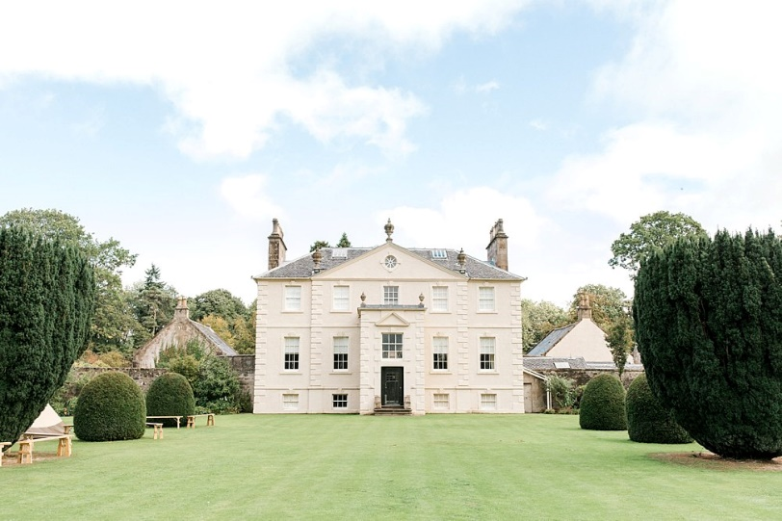
Volunteer Manager:
Visitor Services Manager
Suggested Time Commitment:
TBC- will include some evenings and weekends
Type of role:
Ongoing role – no defined end date

Why do you need me?
We care for a beautiful estate, popular with people from all over Glasgow and the surrounding areas. We need your help to manage our growing events programme. We run events all year round, covering everything from Christmas fairs to outdoor theatre in the summer months. If you’re a friendly and organised person, and want to volunteer at a stunning historic location, we would love to hear from you!
Greenbank Garden is a 18th century Georgian Mansion located just outside Glasgow, once home to the Allason family. The house changed hands many times over the succeeding three centuries, before being donated to the NTS in 1976.
What’s included in the role?
- Welcoming visitors to the event/estate
- Helping to set up and dismantle events
- Answering questions and pointing people in the right direction
- Acting as an ambassador to the NTS
Why should I volunteer in this role?
This role will give you the opportunity to speak to people from all over the country (and indeed the world). You will also be contributing to your local community and helping to welcome people to a range of fantastic events. You will have the opportunity to peak behind the scenes of our beautiful historic house and grounds. Trust volunteers can attend special events such as training sessions and are recognised for their work through our national thank you programmes.

Who will I be working with?
You will be working with a team of other volunteers and Trust employees. If you need help while volunteering, your volunteer manager or another appointed person will also be around to assist.
Do I need any previous experience for this role?
In general, you don’t need any specific experience or qualifications to volunteer with us.
For this role, we’re looking for someone who is enthusiastic about the work of the Trust, passionate about its values and objectives, and is happy to engage with people of all ages and background. You’ll be able to provide clear and helpful information to our visitors, conveying your interest and enthusiasm for Greenbank Garden and its history to a wide variety of people. This role will involve outdoor working, occasional wet weather, and lifting.
We’ll provide an induction and training for you (all about the Trust, its values and your role) to get started, and we’ll also provide training sessions to help you deliver your tours. You’ll also have free access to all the courses in our online e-learning system.
Who can volunteer with the Trust?
We have an Equality and Diversity policy, and our volunteering opportunities are open to anyone to apply. After you apply, we’ll get in touch to arrange an informal chat with you, to help you understand a bit more about the role and see if it’s right for you.
What if I need some extra help to volunteer?
Most of our volunteer roles are flexible and can be tailored to meet your needs. Our volunteer managers will be happy to discuss any help that you might need to volunteer, including adapting the role or assisting with volunteer expenses, when you first meet up.
Will you carry out any checks before I can start this role?
For this role, we don’t carry out reference checks, and you won’t be required to have a criminal record check. If there’s any information you’d like to share with us, you will have the opportunity to do this when completing your application / registration form.
What’s the next step?
You can apply using the form available through our website nts.org.uk/volunteering-jobs/find-a-volunteering-opportunity
To apply, or to find out some more information, please contact Julie Gilliland, jgilliland@nts.org.uk

