Glencoe National Nature Reserve
Ranger Volunteer Role Description
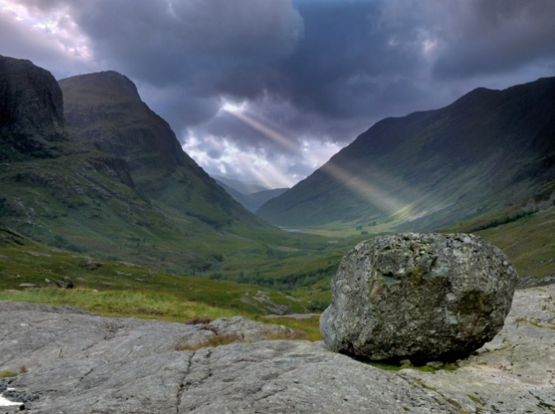
Why do you need me?

Volunteer Rangers play a key role in enabling the National Trust for Scotland to continue our vital conservation and engagement activities in this iconic Highland landscape.

You’ll be an integral part of the Ranger team with other volunteers and Trust employees. You will be supported to enable you to carry out your duties and make a positive contribution to the management of Glencoe National Nature Reserve, and more widely, Scotland’s natural heritage.
Suggested Time Commitment:

Flexible. Where possible, we will work around your availability. Ideally, we would like you to agree to a regular pattern, weekly, fortnightly or monthly, either weekend or weekdays, depending on the nature of tasks you are participating in. We would be keen on your involvement all year round.

What’s included in the role?

Activities may vary depending on time of year, your level of experience, interests or physical activity levels. We will provide an induction and training for tasks that require specific skills.

- Supporting the Ranger team with a variety of countryside management tasks:

- Footpath condition checks and litter picking
- Caring for a native tree nursery poly tunnel and planting trees
- Archaeological site monitoring, seasonal species surveys and rainfall recording
- Habitat conservation including pond maintenance, and scrub/non-native species clearance
- Path and fencing maintenance and repairs including drain and culvert clearance, strimming/mowing of verges, care of benches and signage
- Recording walker numbers by collecting information from a network of people counting data loggers on our mountain paths

- Welcoming visitors, walkers, campers and local community groups across the estate and at our Visitor Centre:

  - Chatting and sharing information while out on estate ‘patrols’
  - Helping set up seasonal events like kids trails, school activities or group volunteering tasks
  - Assisting in our Visitor Centre’s Information Hub offering visitors advice on walks, things to do, local wildlife, geology or history
  - Capturing photos or videos to use in publicity, social media and learning resources

Do I need any previous experience or skills for this role?

- For this role, we’re looking for someone who is enthusiastic about the work of the National Trust for Scotland and passionate about our charity’s values and objectives
- Some knowledge of/interest in Scotland’s countryside and wildlife, and practical conservation skills, would be useful but not essential as you will pick this up!
- Willingness to engage with people of all ages and backgrounds as you will be an ambassador for our charity while volunteering
- Ability to take responsibility and operate under your own initiative is important in this role
- A full clean driving licence is essential

Who can volunteer with the Trust?

We have an Equality and Diversity policy, and our volunteering opportunities are open to anyone to apply. Please be aware that walking long distances on rugged terrain and physically demanding tasks done outdoors in all weathers are part of this role. After you apply, we’ll get in touch to arrange an informal chat with you, to help you understand a bit more about the role and see if it’s right for you.

Benefits of volunteering

Whether you want to learn new skills, or share your experience and free time, volunteering offers a wide range of benefits for your physical and mental health. You will get training and support as part of our team, out of pocket travel expenses if you require them, plus volunteers are entitled to a discount card after 40 hours volunteering, which giving free entry into NTS and NT properties and a 20% discount in NTS shops.

Will the Trust carry out any checks before you can start this role?

This role potentially involves working with young people or vulnerable adults, so we may need to carry out a Protection of Vulnerable Groups disclosure check before you start.

What’s the next step?

Contact us here at Glencoe if you would like more information about the role or would like to join our volunteer team. Call 01855 811307 and ask for Scott McCombie – Senior Ranger or email smccombie@nts.org.uk

