Long-term Volunteer Ranger – Glencoe NNR
Volunteer Role Description

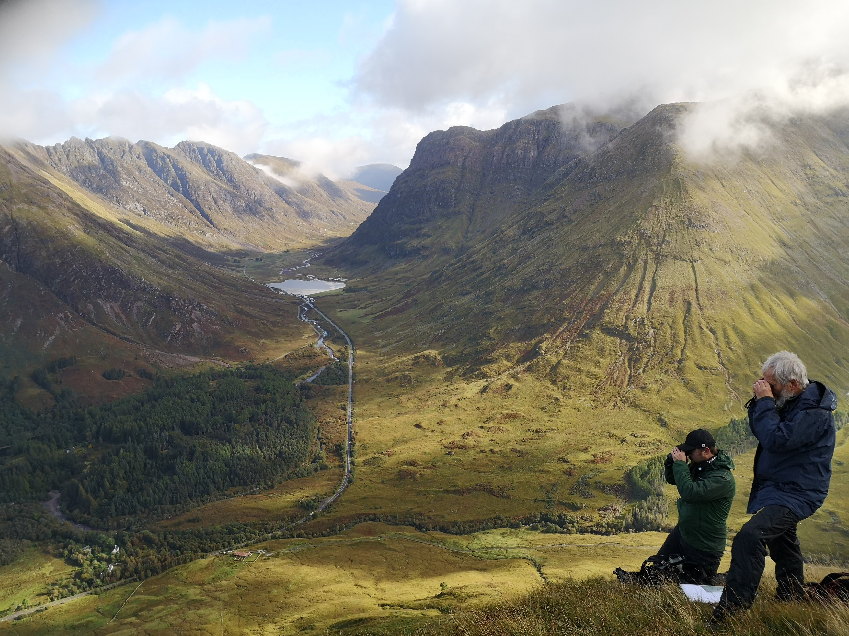

Thank you for your interest in volunteering with the National Trust for Scotland. For more information, or to apply for this role, please contact:

Scott McCombie – Senior Ranger.
Email: smccombie@nts.org.uk Telephone: 01855 811 307

What does this volunteer role involve?

Type of role: Fixed term – around 7 months (April to October) with opportunity to stay in winter.
Suggested Time Commitment: 35 – 40hrs per week (includes some weekends and evenings on a rota)
Why do you need me?
Our charity cares for Glencoe National Nature Reserve, a world-famous mountain landscape which attracts millions of visitors every year. Our Ranger team plays a crucial role in ensuring that our conservation ambitions go hand in hand with welcoming our local community and visitors from across the globe to this well-loved place.
As an integral part of the team, volunteer rangers are invaluable to enable us to carry out practical conservation management, habitat monitoring, environmental education and a busy events programme for the public.
What’s included in the role?

The work is as varied as the weather in Glencoe. We also encourage the development of your own areas of personal interest, which would be of practical use on the property. You will be supported with coaching and training to carry out your duties and make a positive contribution to the management of Glencoe National Nature Reserve.

Key duties include:

- Assist with a variety of ecological surveys, including habitat impact assessments, monitoring rare plants and willow scrub, butterfly surveys, bumblebee surveys, wetland bird survey (WeBs) moth trap surveys and rainfall recording

- Assist in running a native tree nursery and planting out saplings in the landscape

- Carry out litter clearance, footpath and fencing checks, maintenance and repairs

- Carry out invasive/non-native species clearance and strimming of path networks

- Promote responsible outdoor access and the Scottish Outdoor Access Code by chatting with walkers and campers while out in the NNR

- Assist in the planning and delivery of the events programme including guided walks, Land Rover Safaris and seasonal themed family activities

- Welcome visitors, answer questions and offer advice on walks and wildlife at our Visitor Centre Info Hub

- Assist with the provision of environmental education activities for primary and secondary schools, plus other community groups

- Take photos and provide story content for use on social media, website, leaflets and signage

- Assist with the supervision of groups of conservation volunteers carrying out practical conservation tasks

There will be occasional lone working for which we have a lone working procedure in place.

Accommodation

This role comes with free accommodation in a shared “Bothy”, in a beautiful location, half a mile from the Visitor Centre and offices, 2.5 miles from Glencoe village. The Bothy comprises two private bedrooms, a living room / kitchen, a shower and two toilets.

It offers basic, but homely and cosy facilities, including a solid fuel stove, hot and cold running water, electric cooker, kettle, microwave and washing machine. Firewood is collected from woodland management activities. There is no WIFI in the Bothy, but there is very good 4G mobile internet depending on your device and network.

The nearest shops are Glencoe village (2.5 miles) and Ballachulish (3.5 miles). We can provide a vehicle once a week, so that a weekly shop can be done at the supermarket in Fort William (22 miles). There is a regular daily bus service to both Glasgow and Fort William. The Clachaig Inn is your nearest pub, within walking distance!

Socialising

Other seasonal volunteers and staff live in accommodation on the estate, providing a ready opportunity to make new friends. The local community is also friendly and welcoming and we are happy to help you make local connections if you are looking for adventure buddies. There are plenty of social activities within a short radius.

Opportunities for employment in the area

There is the possibility of supplementing your income with seasonal employment in our Visitor Centre’s café, shop or welcome teams. Many previous volunteers have also worked a few evenings a week in local pubs or restaurants.

Do I need any previous experience?

For this role, we’re looking for someone who is enthusiastic about the work of the National Trust for Scotland and passionate about our charity’s values and objectives. Some prior skills, knowledge or experience of the key duties (featured above) is helpful but not essential.

This role will suit someone who is happy to engage with people of all ages and backgrounds, working as part of a team and under own initiative, with good communication skills. You will need to be prepared to do physically demanding tasks and walk long distances across rugged and mountainous terrain in all weathers. You will need to be comfortable living in a remote location with limited facilities.

A full clean driving licence is essential.

Why should I volunteer in this role?

As a National Trust for Scotland volunteer, you will be helping to care for and provide access to amazing places. You may learn new things, develop new skills, make new friends. You will certainly become a valued part of the NTS team. You can find out more about how we recognise the contribution of our volunteers and lots of other useful information, including payment of expenses, in our Volunteer Handbook NTS Volunteer Handbook 2023

This is a fantastic opportunity to be part of a busy Ranger team, gain a wide range of experiences and skills, while making a real difference with your enthusiasm for Scotland’s natural heritage.

This would suit someone starting out on a career in the conservation sector or simply wishing to do something unique and worthwhile later in life. Many previous long-term volunteer rangers of Glencoe have gone on to gain full time employment in the environmental or countryside management, both working for the NTS as well as other well-reputed organisations.

This is a unique opportunity to live in the heart of the Glen and immerse yourselves in everything that makes Glencoe special. You will have the chance to explore its mountains, history, geology and wildlife, both at work and in your spare time.

What next?

If you would like to apply, please complete the Volunteer Note of Interest Form and send it to the contact above. If you would like some extra information before applying, you can contact the ranger team at glencoe@nts.org.uk or phone 01855 811307. The closing date for applications is 16th February 2024

Last Revision Date: December 2023

