Glencoe Turf & Creel House Guide
Volunteer Role Description
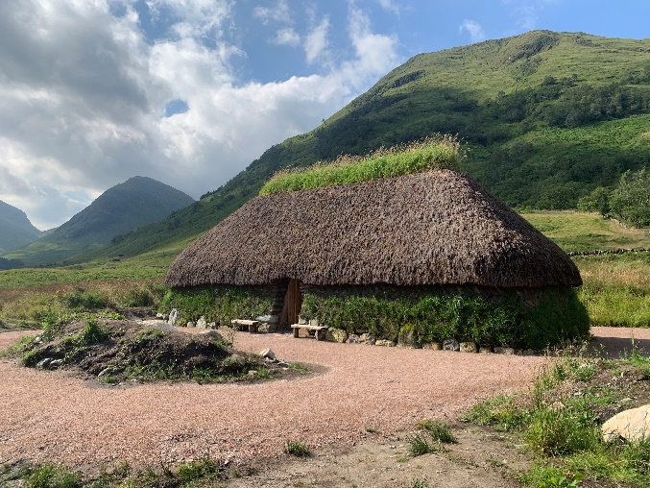
Volunteer Managers:

Glencoe, Visitor Service Supervisor
(Welcome & Engagement)
Suggested Time Commitment:

Generally, 3 to 6 hours a day, on a weekly, fortnightly or monthly basis.
Why do you need me?

Are you passionate about Highland history and heritage? Interested in sharing your enthusiasm and knowledge with others?

We’re looking for enthusiastic volunteers to provide great Highland hospitality and assist with welcoming visitors from around the world to this unique reconstruction of one of the lost homes of the MacDonalds of Glencoe.

Situated next to our Visitor Centre, amidst some of Scotland’s most iconic mountain scenery, our Turf & Creel House is a portal to the 17th century – a time of clans, cattle and a rich Gaelic culture.

As a volunteer guide, you will have the chance to engage with a wide range of people, while gaining hands-on experience of caring for a one-of-a-kind archaeological reconstruction.

As a charity, the National Trust for Scotland relies on the support of volunteers, members and donations to continue what we do.

What does it involve?

Tasks may include:

- Welcoming visitors and helping them to enjoy their visit

- Providing information, answering questions and sharing stories

- Opening the turf & creel house site in the morning or closing up at end-of-day

- Supporting or leading tours, engagement activities or events to bring the space to life

- Ensuring the surrounding area is well-presented through litter-picking and general tidying

- Working as part of a team to offer visitors a positive view of the National Trust for Scotland

Who will I be working with?

This role will involve spending time outdoors at the Turf & Creel House site, inside the Turf & Creel House itself, and inside our nearby Visitor Centre. You may be working alongside other volunteers and Trust employees, or may be on your own, in contact with colleagues by radio. If you need help while volunteering, your volunteer manager or other supervisors will be available to assist.

Do I need any previous experience for this role?

In general, you don’t need any specific experience or qualifications to volunteer with us.
For this role, we’re looking for someone who is enthusiastic about the work of the Trust, passionate about our values, and happy to engage with people of all ages and backgrounds. You’ll have a good eye for detail to ensure our customers receive a great service – a love for Glencoe and its people, history and heritage is a bonus!

We’ll provide an induction and training - all about the Trust, Glencoe National Nature Reserve, our Visitor Centre and your role - to help you get started, and we’ll help you to continue learning while you’re volunteering with us. This includes free access to all of the courses in our online e-learning system, some of which are mandatory to become part of our team.

Who can volunteer with the Trust?

We have an Equality and Diversity policy, and our volunteering opportunities are open to anyone to apply. After you apply, we’ll get in touch to arrange an informal chat with you, to help you understand a bit more about the role and see if it’s right for you.

What if I need some extra help to volunteer?

Most of our volunteer roles are flexible and can be tailored to meet your needs. Our volunteer managers will be happy to discuss any help that you might need to volunteer, including adapting the role or assisting with volunteer expenses, when you first meet up.

What’s the next step?

If you would like to apply, or need some extra information before applying, contact us at: glencoe@nts.org.uk

