**Project Volunteer – Fyvie Castle**

**Role Description**

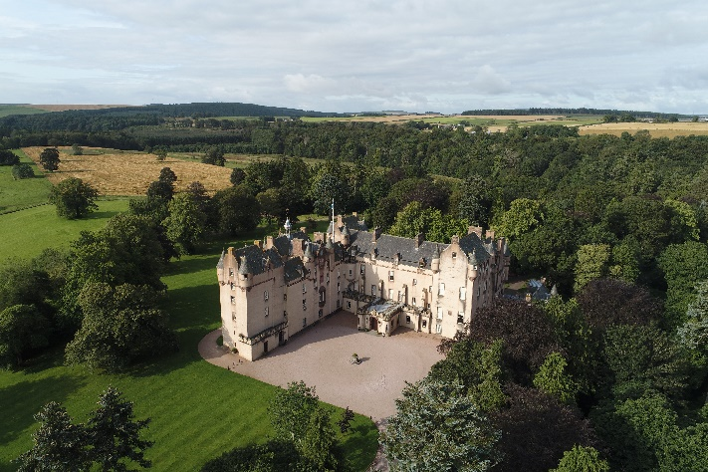

|  |  |
| --- | --- |
| **Directorate**: North East |  |
| **Volunteer Manager**:  Visitor Services Manager –  Fyvie Castle |
| **Suggested Time Commitment**:  Ad-hoc, hours vary depending on activity |
| **Type of role:**  Various |

**Why do you need me?**

Set in the heart of Aberdeenshire, Fyvie Castle is an imposing 800-year-old fortress with a surrounding estate and garden. Home to a unique collection, native and non-native plant species, and wildlife, the National Trust for Scotland is embarking on a Major Project to conserve the Castle and its collection as well as save the B-listed, at-risk Old Home Farm buildings and enhance the visitor experience across the site. We are looking for enthusiastic volunteers to assist with elements of project delivery, which could include gardening, collections care, events, research, and estate work.

**What’s included in the role?**

* Providing a warm welcome to all our visitors.
* General collections care, preventive conservation and housekeeping activities such as cleaning, carrying out object audits, organising storage areas and pest management.
* Supporting the creation of new facilities to the estate including footpaths, natural play, nature spotting areas and an outdoor woodland school.
* Supporting project initiatives including sustainable re-use of salvaged materials, clearing of vegetation around buildings and salvaged items from within buildings.
* General garden maintenance which includes weeding, mulching, planting.
* Carry out litter clearance, footpath and fencing checks, maintenance and repairs.
* Cary out invasive/non-native species clearance.
* Event set-up including moving tables and chairs and erecting gazebos.
* Assisting at community and corporate events, e.g. directing visitors and occasionally serving refreshments.
* Ensuring the safety of all volunteers, staff and visitors by following health and safety guidance.
* Conducting research to support project learning.
* Acting as an ambassador for Fyvie and for the NTS and supporting promotion of the project.

**Example current volunteer projects**

Regular volunteering opportunities are available to support daily management and care of the site, this includes work within the castle (guiding, collections care, or helping in the shop or tearoom) and to the gardens and estate. Volunteering opportunities are also available to support events of all types and scales which are delivered all year round.

In addition to this several project focused activities are available, with new opportunities arising as the project progresses. Current example project activities include;

* **Second-hand bookshop:** We are looking to create a second-hand bookshop inside the castle and are in the process of setting it up. This includes preparing the space, setting up shelving and organising donations into categories for display.
* **Old Home Farm collection:** Having recently purchased Old Home Farm, we have acquired the contents of the buildings, which need to be cleaned, photographed and catalogued.
* **Creative fundraising:** We have collected salvaged materials from buildings including timber, stone and slate. We are seeking hands-on, creative people to support re-use of these materials, in particular creating items which can support fundraising for the essential conservation work required.
* **Research:** We have a number of research topics focused around the history of Fyvie and the families who owned, lived and worked on the estate. This includes cataloguing and photographing drawings, and accessing archives to learn more about the history of Fyvie.
* **Natural heritage engagement:** We are seeking to create new areas to the estate to provide facilities for people of all ages to engage with nature and the landscape. This will be a hands-on task to support creation of footpaths, boardwalks, and structures formed from natural materials including habitats for wildlife.

**Why should I volunteer in this role?**

We are a passionate and enthusiastic, hands-on team who are looking for like-minded people to join us on this exciting project. Whilst learning more about Fyvie Castle, conservation, and visitor experience, this is an excellent opportunity to develop practical skills and knowledge and to gain privileged ‘behind the scenes’ access.

Volunteer benefits include

* Volunteer Pass.
* Joining part of the NTS community, meeting new people.
* Trust volunteers can attend special events such as training sessions and are recognised for their work through our national ‘thank you’ programmes. We also host an annual volunteers tea party!

**Who will I be working with?**

The Fyvie Project team is made up of Trust employees from all roles, but key team members will include:

* Fyvie Project Director
* Fyvie Project Delivery Manager
* Fyvie Visitor Services Manager
* Fyvie Head Gardener
* Fyvie Estate worker
* Fyvie Collections Care Assistant
* Fyvie Events Supervisor
* Northeast Ranger Service
* Northeast Community Engagement Officer

**Do I need any previous experience for this role?**

No, you don’t need any specific experience or qualifications to volunteer with us.

For this role, we’re looking for someone who is:

* Enthusiastic about the work of the Trust and passionate about its values and objectives.
* A good team member.
* Aware, with a respect and understanding of the need for a careful and focused approach whilst working in the historic and natural environment.
* Able to listen and follow direction, using correct methods and procedures for the task.
* Happy to engage with people of all ages and backgrounds.
* Interested in aspects of Fyvie Castle’s story.

We’ll provide an induction and training for you (all about the Trust, its values and your role) to get started, and we’ll help you keep learning while you’re volunteering with us. This includes free access to all the courses in our online e-learning system.

**Who can volunteer with the Trust?**

We have an Equality and Diversity policy, and our volunteering opportunities are open to anyone to apply. After you apply, we’ll get in touch to arrange an informal chat with you, to help you understand a bit more about the role and see if it’s right for you.

While we strive to be an inclusive and accessible site, Fyvie Castle has some limited access features. We have detailed access information on our website: [Fyvie Castle accessibility guide | National Trust for Scotland (nts.org.uk)](https://www.nts.org.uk/accessibility/fyvie-castle-accessibility-guide)

**What if I need some extra help to volunteer?**

Most of our volunteer roles are flexible and can be tailored to meet your needs. Our volunteer manager will be happy to discuss any help that you might need to volunteer, including adapting the role or assisting with volunteer expenses, when you first meet up.

**Will you carry out any checks before I can start this role?**

For this role, we don’t carry out reference checks, and you won’t be required to have a criminal record check. If there’s any information you’d like to share with us, you will have the opportunity to do this when completing your application / registration form.

**What’s the next step?**

You can apply online now for this role through our website application portal.

If you would like some extra information before applying or would like to request an application form be sent to you, you can contact the Visitor Services Manager – Fyvie Castle on [Fyvie@nts.org.uk](mailto:Fyvie@nts.org.uk) or the office on 01651 891266.

**Last Revision Date**: 04/06/2025