Corrieshalloch Gorge Conservation Volunteer
Volunteer Role Description

Region:  Highlands & Islands | 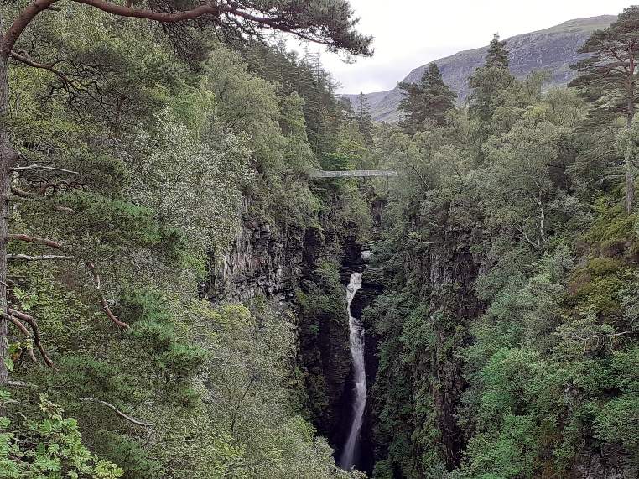
Volunteer Manager:
Aidan Bell, Estate Supervisor
Suggested Time Commitment:
As mutually convenient
Type of role:
Ongoing – no defined end date

Why do you need me?
Situated in Wester Ross in the north-west Highlands, Corrieshalloch Gorge is something of a hidden gem nestled in the hills around Loch Broom. Designated as a National Nature Reserve in 1967, it is the smallest of 43 NNRs in Scotland, but by no means the least spectacular! The Reserve has one of the most significant slot gorges in Britain, providing a microclimate and habitat that is home to an abundance of wildlife. Gifted to the National Trust for Scotland in 1945 by John Calder, the NTS now cares for this special place for the benefit of wildlife and people, welcoming over 85,000 visitors each year. Our volunteers are key to helping us look after this wonderful landscape, welcome our visitors and ensure that they enjoy their experience. Our conservation volunteers help with a wide range of practical tasks across this fascinating Reserve, as well as promoting the Trust and its valuable conservation work.

What’s included in the role?
This is very much a hands-on practical role, where we manage the Reserve for conservation and recreation, including:
- Engaging with visitors and answering their questions about Corrieshalloch, its history, landscape, walks and wildlife
- Wildlife surveys and monitoring
- Footpath and infrastructure repairs, including gates and fences
- Woodland and habitat management
- Assisting with the control of invasive species

Why should I volunteer in this role?
You will have the opportunity to develop your interests and skills in environmental conservation, land and woodland management, alongside the maintenance and presentation of a heritage attraction. There will be a wide variety of tasks and fun to be had! Trust volunteers are also recognised for their work through our national ‘thank you’ programmes.

Who will I be working with?
As it’s a small team, you’ll be working directly with your volunteer manager, staff and/or with other estate volunteers. In some instances there may be some lone working, but the Safe System of Work for lone working will be explained to you where necessary.

Do I need any previous experience for this role?
In general, you don’t need any specific experience or qualifications to volunteer with us, as relevant guidance and training will be provided where required. However, if you do have any relevant experience, qualifications or skills that you think you could contribute, please let us know. You will also need to be reasonably fit and able-bodied to carry out physical work over rough terrain. We’ll provide an induction and training for you (all about the Trust, its values and your role) to get started, and we’ll help you keep learning while you’re volunteering with us.

Who can volunteer with the Trust?
We have an Equality and Diversity policy, and our volunteering opportunities are open to anyone to apply. After you apply, we’ll get in touch to arrange an informal chat with you, to help you understand a bit more about the role and see if it’s right for you.

What if I need some extra help to volunteer?
Most of our volunteer roles are flexible and can be tailored to meet your needs. Our volunteer managers will be happy to discuss any help that you might need to volunteer, including adapting the role or assisting with volunteer expenses, when you first meet up.

Will you carry out any checks before I can start this role?
For this role, we don’t carry out reference checks, and you won’t be required to have a criminal record check. If there’s any information you’d like to share with us, you will have the opportunity to do this when completing your application / registration form.

What’s the next step?
You can apply online now for this role through our website application portal.
If you would like some extra information before applying, you can contact:

Email: corrieshalloch@nts.org.uk
Last Revision Date: AB 12/09/2023

