COLLECTIONS CARE VOLUNTEER – CRATHES CASTLE
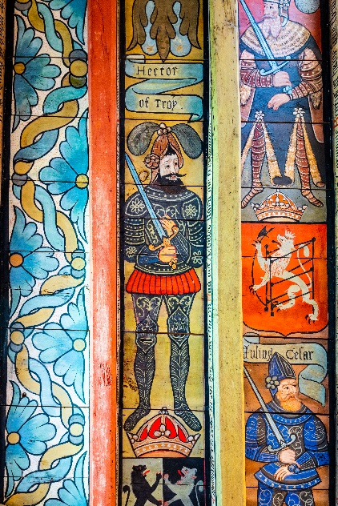

Thank you for your interest in volunteering with the National Trust for Scotland. For more information, or to apply for this role, please contact:

Douglas Kyle, Visitor Service Manager, dkyle@nts.org.uk

What does this volunteer role involve?
Include:
- What you’ll be doing: cleaning, engaging with the public around collections, working closely with a team of volunteers and staff.
- How much time you’ll be giving: 1 day a week
- The team you’ll be volunteering with: Collection Care

Do I need any previous experience?
Include either:
- Enthusiastic about the work of the Trust
- Happy to talk to the public
- A good team player
- Willing to help with what needs doing

We’ll provide an induction and training for you as needed along with support to help you carry out your volunteering role.

Why should I volunteer in this role?
As a National Trust for Scotland volunteer, you will be helping to care for and provide access to amazing places. You may learn new things, develop new skills, make new friends. You will certainly become a valued part of the NTS team. You can find out more about how we recognise the contribution of our volunteers and lots of other useful information, including payment of expenses, in our Volunteer Handbook 2024

What next?
If you would like to apply, please contact the person listed above. We will be in touch to arrange
- to have an informal chat / a taster session / for you to shadow an existing volunteer

Last Revision Date: August 2023

