 | Job Description | January 2026

Role: Commis Chef | Region / Department: South & West
Reports to: Head Chef | Pay Band: Grade 2 Lower - 12.60 per hour
Location: 215-217 Sauchiehall Street, Mackintosh at the Willow. | Type of Contract: Full-Time – 40 Hours Per Week, Permanent

Mackintosh at the Willow is the home of the original Willow Tea Rooms Building at 217 Sauchiehall Street. It was first opened by Miss Cranston in 1903 and designed by Charles Rennie Mackintosh in collaboration with his wife, Margaret Macdonald. Following a detailed restoration project in 2018, the building is now back to its former glory as a unique tearoom over three floors. It also includes additional events spaces, an exhibition and a gift shop.

JOB PURPOSE

Working alongside the kitchen team to complete daily kitchen activities, including measuring and preparing ingredients for the Chef de Partie or Head Chef. To support the kitchen team with basic food preparation, ensuring food quality and freshness, and dealing with deliveries and stock rotation. To maintain standards of food hygiene and ensuring that the section is clean and tidy and appropriately set up for service.

KEY RESPONSIBILITIES AND ACCOUNTABILITIES

- Ability to prioritise and manage own time.
- Basic food prep and ability to follow instructions.
- compliance with H&S legislation.
- completion of all relevant issued training.
- Maintaining high standards of hygiene.
- Preparing the ingredients for a Chef De Partie or Head Chef.
- Measuring dish ingredients and portion sizes accurately.
- Dealing with deliveries and stock rotation.
- Section working; ensuring that the section is clean and tidy and appropriately set up for service.
- Ability to follow instructions and spec sheets.
- Adhering to all allergen control practices.

REQUIRED QUALIFICATIONS, SKILLS, EXPERIENCE & KNOWLEDGE

Qualifications

Essential
- Professional Food Qualification or relevant experience
Experience

Essential
- Basic culinary skills, such as knife skills, and knowledge of different ingredients, cooking equipment and kitchen procedures.
- Ability to follow spec sheets.
- Basic food preparation and ability to follow instructions.

Desirable
- 1 years’ experience in a restaurant or food outlet preferred.

Organisational chart
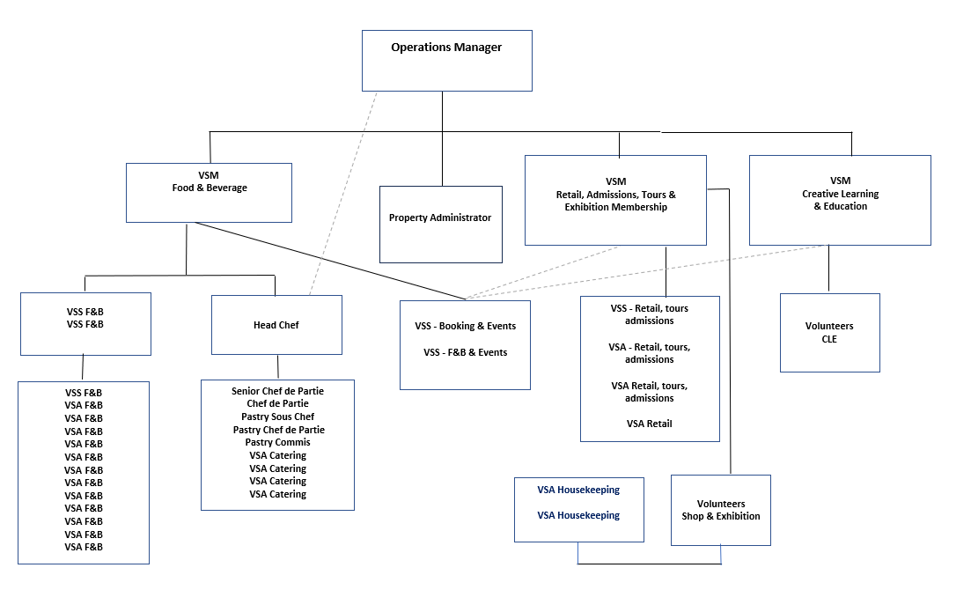

DIMENSIONS AND SCOPE OF JOB

Scale
- n/a

People Management
- n/a

Finance Management
- n/a

Tools / equipment / systems
- Catering equipment including cooking equipment and dishwashers.

Why come and work with us?
Being an employee of the National Trust for Scotland gives you the chance to work in some of Scotland’s most special places.
Your employee card gives free entry to you, any of your children under the age of 18 and one other adult to National Trust for Scotland and National Trust properties
- Good work/life balance & TOIL scheme in place.
- A 50% discount for food and drinks, on-shift, for all workforce either based at the property or attending the property on Trust business
- 20% discount on retail purchases in National Trust for Scotland shops (T&Cs apply).
- A 20% discount for food and drink, off-shift, for all workforce visiting a Trust location; this will extend to family and friends when visiting together.
- Generous defined contribution pension scheme
- Generous annual holiday entitlement as soon as you start working with the Trust – 30 days per year plus 7½ days around the festive period
- 20% discount on the rental price of all National Trust for Scotland self-catering holiday accommodation managed by Sykes (our partner organisation), and 10% for other Sykes properties (T&Cs apply)

The Purpose, Context, Key Responsibilities, and Person Specification reflect the requirements of the job at the time of issue. The Trust reserves the right to amend these with appropriate consultation and/or request the post-holder to undertake any activities that it believes to be reasonable within the broad scope of the job or general abilities.

How to Apply

Interested applicants should forward their Curriculum Vitae (CV) or an Application Form to the People Services Department (Applications) by email via workforus@nts.org.uk

Please ensure your CV includes your full name and contact details, the CV file sent to us should be titled your first initial and surname. When submitting your CV please state the position and job location of the vacancy you are applying for in the subject title or body of your email: For example, "Commis Chef – Mackintosh at the Willow"

