 | Job Description | February 2023

Role: Visitor Services Supervisor | Region / Department: Edinburgh & East
Reports to: Visitor Services Manager | Pay Band: Grade 3 Lower (£24,737) pro rata
Location: Kellie Castle & Gardens | Type of Contract: Fixed term, 40 hours a a week (March to October) including regular weekend work
COST CENTRE: 3KEC | ACTIVITY CODE: TRZ
Note:
The post is subject to the standard terms and conditions provided with the application pack and the following special terms also apply: Available to work weekends, no evening work planned (unless arranged for a specific function). A PVG check is required (basic disclosure)

JOB PURPOSE
To provide operational coordination and supervision of catering, retail, visitor services, and events at in line with the Trust’s policies, priorities, performance standards and targets to contribute to the enjoyment of the property by visitors and members, and help ensure commercial, financial, and conservation objectives are achieved.
The Visitor Services Supervisor at a Trust property plays a pivotal role ensuring that the management objectives are achieved through excellent customer service. With delegated responsibility for catering, retail, events and duty management this job is very often the “face” of the Trust to visitors and suppliers, directly influencing public perceptions of the Trust and is crucial to developing and maintaining the property’s local/national reputation.

KEY RESPONSIBILITIES AND ACCOUNTABILITIES
Supervising/undertaking the day-to-day operation of the property and environs to ensure an excellent customer/visitor experience. This includes supervision of:
- Visitor services, events, catering and retail offer (including ordering, merchandising, sales targets).
- Line management of Visitor Services Assistants and volunteers.
- Supervising staff in the café.
- Upholding food and hygiene standards and preparation of food.
- Duty management and oversight/maintenance of the property.
- Ensure the property social media is managed to generate interest, engagement and help drive visitors.
- Deliver the schools programme to meet the targets for number of visits, revenue generated.
- Support the informal learning and community engagement / outreach activity, e.g. public events.
- Ticketing & Membership sales (to targets) and general customer service (individuals, education visits, other groups).
- Security of the Property.
- Health & Safety procedures, emergency procedures, and environmental procedures.
- Deputising for the Visitor Services Manager on-site and off-site as required.

Responsible for day to day financial administration at the property, including:
- Ensuring the completion of Cash/till reconciliation.
- Week-end reports and reconciliation.
- Completion of the banking and all cash handling processes.

Supporting the Visitor Services Manager with:
- Recruitment; induction; development; and management of all visitor services employees and volunteers such that they understand and are equipped to fulfill their roles to the standards required and that they feel valued, respected and supported.

Working closely with other managers across the Property to deliver a programme of visitor events, which increase visitor numbers, drive secondary spend and support overall Property targets.

Instil a Health & Safety culture across the property, ensuring the team work within the property’s ‘Safe System of Work’ to reduce risk of incidents and accidents to volunteers, employees and visitors.

REQUIRED QUALIFICATIONS, SKILLS, EXPERIENCE & KNOWLEDGE
Qualifications
- No formal educational qualification required (but see “Experience” below).
- A full, clean driving license for driving in the UK.

Desirable
- Food & Hygiene Qualification.
- Current First Aid certification (or willingness to train and use).
- A formal qualification in Catering, Hospitality, Tourism or Event Management.
- A recognised SQA Licensing Qualification e.g. Scottish Personal Licence Holders Certificate and Personal License.

Skills, Experience & Knowledge
Essential
- Significant previous experience of working in an operations role in the visitor/heritage attraction industry – including supervision of staff and/or responsibility for specific activities.
- Previous event coordination/management experience.
- Excellent customer service skills.
- Excellent organisational, administrative and time-management skills with the ability to prioritise and re-prioritise workload to meet changing demands.
- Proven sales skills with the ability to achieve targets.
- The ability to think and act quickly when confronted with emergencies.
- Competent user of Microsoft Office products.
- An understanding and commitment to the aims and objectives of the National Trust for Scotland.
- Access to own transport.

Desirable
- Experience of volunteer management.

DIMENSIONS AND SCOPE OF JOB

Finance Management
- Share responsibility for achieving the income budget together with the Visitor Services Manager.
- Monitor commercial performance and adjust activities to capitalize on sales opportunities and run a cost-effective operation.
- Supervise daily till operations and perform end-of-day income reconciliation.
- Assist the Visitor Services Manager with menu costing and stock-taking.

Tools / equipment / systems
- Access to laptop and relevant online people management, training, financial monitoring and stock ordering systems, including NTS intranet and Microsoft 365.
- EPOS tills and chip and pin machines.
- Fully equipped commercial catering kitchens.
- Use of internal finance and banking systems.

Performance indicators and targets
- Weekly, monthly and annual sales and cost of sales targets.
- Food compliance standards and record-keeping.
- Visitor enjoyment reviews and ratings from visitor surveys and visitor feedback.

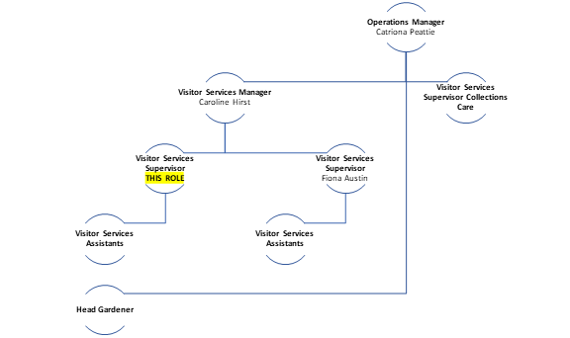

The Key Responsibilities, Scope of Job, and Required Qualifications, Skills, Experience & Knowledge reflect the requirements of the job at the time of issue. The Trust reserves the right to amend these with appropriate consultation and/or request the post-holder to undertake any activities that it believes to be reasonable within the broad scope of the job or his/her general abilities.

Applications
Interested applicants should forward their Curriculum Vitae (CV) or an Application Form to the People Services Department (Applications), The National Trust for Scotland, Hermiston Quay, 5 Cultins Road Edinburgh EH11 4DF, by mail or by email via workforus@nts.org.uk, by first post Friday 17th March 2023.
Please ensure your CV includes your full name and contact details, the CV file sent to us should be titled your first initial and surname. When submitting your CV please state the position and job location of the vacancy you are applying for in the subject title or body of your email: For example "Gardener - Culzean"

